The Ohio State University
Interdisciplinary Graduate Program in

Biophysics



Graduate Student Handbook

2008-2009 Edition

Table of Contents

Topics | Page Numbers
I. Mission Statement | 1
II. Introduction to Biophysics Program | 1
III. Information for Prospective Students | 2
A. General Admission Requirements | 2
B. Pre-Enrollment Contract | 3
IV. Coursework Requirements for 1st & 2nd Year Students | 4
A. 1st Year Course Load | 4
B. 2nd Year Course Load | 4
C. Foundation Courses | 5
D. General Recommendations for Scheduling Classes | 5
E. English Courses for Non-domestic Students | 6
V. Training Tracks: Coursework Options | 7
A. Structural Biology and Molecular Biophysics Track (SBMB) | 8
B. Cellular and Integrative Biophysics Track (CIB) | 12
C. Biological Imaging and Spectroscopy (BIS) | 16
D. Computational Biology and Bioinformatics Track (CBB) | 21
VI. General Biophysics Graduate Program Policies | 25
A. Ph.D. Candidates and Financial Aid | 25
B. Masters Degree Candidates | 26
C. Laboratory Internships | 27
D. A Few Notes about Internships | 29
E. Internship Final Report Form | 30
F. Choosing an Advisor/Being Chosen by an Advisor | 30
G. When the Advisor/Student Relationship Does Not Succeed | 30
H. Vacation Policy | 31
I. Program Probation, Graduate School Probation and Dismissal | 32
J. Ethical and Scientific Misconduct | 33
K. Transfer and Dismissal from the Program | 33
L. Biophysics Student Association | 34
VII. Examination Policies | 36
A. General Overview | 36
B. The Biophysics “Contract” | 36
C. Format of the Written Preliminary Examination | 37
D. Additional Notes and Suggestions Regarding the Preliminary Exam | 39
E. The Written Qualifying Examination | 40
1. Examination Preproposal | 40
2. Format of the Written Qualifying Examination | 41
3. Evaluation and Grading of the Written Qualifying Examination | 42
F. Oral Qualifying Examination | 43
G. Thesis and Oral Thesis Defense | 44
H. Oral Thesis Defense | 45
Appendix A.Ohio State Biophysics Pre-Contract | 46
Appendix B. Worksheet for First and Second Year Class Schedules | 48
Appendix C. Research Internship Final Report Form | 49
Appendix D. Contract Form | 50
Appendix E. Timetable/Worksheet | 55
Appendix F. Student Biographical Sketch Form | 56
Appendix G. Example Letter of Advisor’s Pre-proposal Assurance Letter | 57
Appendix H. Graduate Student Leave of Absence Form | 58
Appendix I. Faculty Agreement to BE an Advisor | 59
Appendix J. Quick Chart for candidacy exam | 60

Mission Statement of The Ohio State University Biophysics Interdisciplinary Graduate Program
- To provide a rigorous educational structure and curriculum for graduate students to develop successful and nationally competitive careers in biophysics.

- To provide an effective University-wide environment that stimulates and promotes interdisciplinary and collaborative research at the interface of physics and biology.

- To provide an interdisciplinary environment for the development and implementation of innovative and highly quantitative, computational, and experimental approaches to important problems at the cutting edge of biomedical research and biotechnology.

II. Introduction to the OSU Biophysics Graduate Program

Biophysics is a highly integrated discipline that can encompass nearly all aspects of biomedical science, from the interaction of various forms of energy with biologically relevant molecules to the mechanical forces involved with limb movement in an intact organism. What makes biophysics uniquely different from other disciplines of biomedical science is its approach to problems. Simply, the biophysicist examines biological systems through the eyes and tools of a physicist. The biophysicist is trained to understand the underlying interactions of energy and matter in living organisms or molecules and to use highly quantitative physical, statistical, and modeling methodologies to understand complex phenomena. The goal of the Program is to provide an educational structure for graduate students at The Ohio State University to develop as scientists at this interface of physics and biology.

We accept students with a wide range of undergraduate training, but all accepted students must have rigorous backgrounds in science and mathematics. There is a lot of flexibility in the curriculum to meet the needs of students with varying backgrounds and goals. Importantly, the Program emphasizes research experience as the greatest teacher, as opposed to exhaustive class work. The general philosophy is that graduate education in science is best acquired as a “research apprenticeship”, where the most valuable education comes from active participation in research and related independent study. Nevertheless, it is extremely important that all students get sufficient fundamental knowledge in biochemistry, biology, chemistry, and physics, regardless of the direction of their research, to successfully complete their qualifying exams and move on to a successful career.

To better organize the curriculum and to provide appropriate mentorship, the program is self-organized into four “training tracks” or divisions. These tracks are oriented toward “experimental approaches” rather than “experimental problems.” To be successful, however, scientists must be “problem oriented” and be willing to embrace any technology or approach that will yield the answers being sought. Scientists who pigeonhole themselves, for example, only as crystallographers, patch clampers, bioinformaticists, magnetic resonance spectroscopists, or modelers often have short careers. Therefore, we expect all students to become familiar with a variety of experimental approaches and applications within these tracks while in their graduate training and also to learn and be willing to embrace new technologies as their research problems unfold and the science advances. On the other hand, one cannot be an expert at everything within the few years of graduate education. Therefore, students are best served by also concentrating and developing a high degree of expertise and rigor in one general approach during their graduate training so that they can use this as a springboard for establishing a reputation of expertise and to promote their career development. This is the purpose of the four tracks, which are the following:

Structural Biology and Molecular Biophysics (SBMB)
Description: Three dimensional structure and function of biological molecules, including proteins, nucleic acids, ligands, lipids, and their interactions. Methods include X-ray crystallography, nuclear magnetic resonance, computational modeling, calorimetry, and optical spectroscopy.

Cellular and Integrative Biophysics (CIB)
Description: Applied physics to understanding living animals and plants, including membrane electrochemical behavior, patch clamping, channel biology, intracellular calcium ion regulation, molecular motors, cytoskeleton , muscle contractile function, nerve function, neural integration, bioenergetics and mitochondrial function, free radical biology, and biomechanics.

Computational Biology and Bioinformatics (CBB)
Description: The use of high-level computational techniques and computer modeling to address biological problems and to model molecular aspects of living cells. The development and use of computer models, simulations, and statistical approaches to interpret large data sets of the genome, proteome and lipid elements of the cell, as well as neural networks and other biologically complex systems.

Biological Imaging and Spectroscopy (BIS)
Description: The application of high-end technology for imaging and detection of chemical and biological processes and structures. Techniques include magnetic resonance (MRI, NMR, EPR, etc.), light/laser spectroscopy, multiphoton and confocal imaging, electron microscopy, optics, fluorescent detection, atomic force microsocopy, and positron emission tomography (PET).

III. Information for Prospective and Students Beginning the Program:

A. General Admission Requirements
The Program admits students with a wide range of science and mathematics backgrounds. Approximately 60% of our incoming students are physics or biophysics majors; about 20% are general chemistry or biochemistry majors, and 20% are mathematics, engineering, or biology majors. Nevertheless, all students in biophysics need to have general knowledge in physics, mathematics, chemistry, and biology.
In general, applicants are encouraged to prepare themselves for a career in biophysics with the following background during their undergraduate training:
- Physics: through particles and waves, quantum mechanics, and thermodynamics.
- Mathematics: differential and integral calculus. Linear algebra is highly recommended.
- Chemistry: inorganic, organic, and physical chemistry.
- Biology: knowledge of at least one biological system, e.g. general biology, microbiology, botany, animal physiology, or plant physiology.
Students who have not completed all of the above requirements in the undergraduate degree can pick up some during their first year of graduate school. Many incoming students need additional background in at least one of these areas. However, the Admissions Committee reviews the applicant’s undergraduate curriculum to evaluate how successful the student could be in completing these requirements in a timely manner and this is part of their evaluation. As an example, pure physics majors who have had no background in chemistry or biology would have a more difficult time in this program compared to physics majors with a more balanced science background including some chemistry and biology.
B. The Biophysics Pre-Enrollment Contract
The OSU Biophysics Graduate program has developed the concept of “contracts.” These are written agreements between the student and the Graduate Program or the student’s Graduate Committee. The “Pre-Contract” is an initial agreement between the student and the Graduate Program, regarding the educational plan. The general “Contract” expands the Pre-contract and includes the content of the Preliminary and Qualifying Examination and any additional coursework needed for career development.
A blank “Pre-contract” for incoming students to use as they design the curriculum for their first two years is in Appendix A. It includes only general requirements of all students in the program and does not represent the specialized training that is expected of students in each of the four tracks. The requirements of the contract can be met several ways. 1) The student could have met the requirements in previous undergraduate or graduate education, 2) through new undergraduate or preferably graduate level courses at OSU and 3) by evidence of self-study of equivalent material and/or proof by oral or written examinations provided by the graduate faculty.
A note on biochemistry: With very few exceptions, all areas of modern biophysics require some background in biochemistry. Within it is encompassed the “language of biology” to the extent that even if a student’s research is, for example, in pure magnetic resonance imaging or pure computational bioinformatics, it is necessary to learn the language in order to communicate with other biophysicists and biological scientists and to get a general understanding of the molecular basis of living organisms.

IV. General Course Load Requirements for 1st and 2nd Year Students

- First Year Course Load

By the end of the summer of the first year of enrollment, students must achieve a MINIMUM of 20 total graduate credit hours of which 17 credit hours are Foundation Courses. Foundation courses (listed below) are identified by the Biophysics Graduate Committee as critical, graded courses that are universally applicable and fundamental to developing a knowledge base in biophysics and the language and methods of biology. Included in the 17 credit hours, all first year students must complete the three-quarter Introduction to Biophysics series (Neuroscience 702, Biophysics 702, Physics 780.20; 10 total credits) and a suitable graduate level Biochemistry series. The Biophysical Chemistry Series is also considered a primary part of the foundation course requirements, and is required if the student has had no physical biochemistry background and is recommended for all others. Note that 20 credit hours can be completed in three quarters by taking two, 3-4 credit hour courses per quarter, (i.e., considered a minimum course load for first year students). Failure to be on schedule to meet these requirements in the first year will result in a status of “Program Probation,” possible loss of support and/or loss of active status in the program. Note: students can petition the Graduate Studies Committee for specific graded courses to be considered among this fundamental list which might be unique to the student’s career goals or background.

Students in the first year are required to seek permission of the Graduate Studies Chair or Program Director BEFORE dropping scheduled courses. There are no University rules requiring this, but failure to get permission to drop a course may result in change of status in the program.

First year students are expected to be actively involved in research rotations during the entire first year of enrollment. A minimum of two credit hours of 999 (Thesis Research) is required each quarter. Enrollment in the Biophysics Seminar series (1 c) is also required for autumn, winter and spring quarters (see below for all students). During the autumn quarter, students may be asked to also enroll in the Biochemistry Seminar Program 760, which is a combined Ohio State Biochemistry Program/Biophysics/Molecular Cellular and Developmental Biology/Neuroscience Graduate Studies Program graduate seminar, designed to help students with developing a career in science.

- Second Year Course Load

Prior to the General Qualifying Exam, all students must achieve a MINIMUM of 12 ADDITIONAL credits of recommended and approved coursework within the “Core” curriculum of their designated training track, for a total of 32 credit hours of combined “Foundation” and “Core” curriculum. Note that this requirement does not include research credit hours (999) or seminar credit hours (e.g. Physics 801) and is considered an absolute minimum. Most training tracks will require larger course requirements than this minimum. Students with unique research directions may petition the Graduate Studies Committee to combine coursework from different research tracks or to add alternate, but appropriate, courses to meet their specific needs. Students with a master’s degree and extensive graduate training can petition the Graduate Studies Committee to waive some of these requirements, based upon proof of previous training. Waiving requirements does not necessarily involve transfer of credits. Approval of direct transfer of credit to The Ohio State University Graduate School can occur only from credits earned at comparable U.S. universities with the joint approval of the Graduate Studies Committee and the Graduate School.

All Biophysics students are required to attend the Biophysics seminar in autumn, winter and spring quarters each year. Students who have not passed their candidacy exam must enroll in the Biophysics seminar course and obtain a satisfactory grade. Students past their candidacy exam should not register for the seminar class but are still required to attend in the same amount of seminars as required for a passing grade if taken for credit. Conflicts with other course requirements and teaching assignments must be pre-approved by a Director of the Program or the Graduate Studies Committee Chair.

C. Accepted “FOUNDATION” Courses

Biophysics (required)
Neuroscience 702 (3 credit hours) (cellular biophysics).
Biophysics 702 (3 cr hr) (methodological approaches to biophysical studies).
Physics 780.20 (4 cr hr) Introduction to Biophysics.

Biochemistry (At least One Graduate Level Biochemistry Series Required)
Biochemistry and Molecular Biology 613,614 (615 optional) 4 cr hr each.
Biochemistry 511 5 cr hr.
Molecular and Cellular Biochemistry 761 (Proteins), Biochemistry 766 (Nucleic Acids), Biochemistry 763 (Membranes).

Physical Biochemistry (Highly recommended, required if no Physical Chemistry)
Physical Biochemistry 721.01, 721.02, 721.03.

Biochemistry Laboratory Courses
Biochemistry 521 Laboratory 5 cr hr.
Microbiology 571 Laboratory 5 cr hr.
Biochemistry 706, 708, or 710 Laboratory 5 cr hr.

Integrated Life Sciences
Physiology 601, 602 5 cr hr each.
Plant Physiology 630, 631 3 cr hr each.
Microbiology 520, 521 5 cr hr each.
Medical Microbiology 625, 626 5 cr hr each.
Molecular Genetics 605, 606 4 cr hr each.
Cell Biology (Mol. Gen) 607 3 cr hr.

Computer Science
Computer Science Engineering (CSE) 541 (Elementary Numerical Methods).
CSE 670 (Introduction to Database Systems) 3 cr hr.
CSE 680 (Introduction to Analysis of Algorithms) 3 cr hr.

D. General Recommendations For Scheduling Classes

Students are asked, in the first quarter of enrollment, to plan a curriculum for the first two years (See Form in Appendix B). Based on the current Graduate School Handbook (http://www.gradsch.ohio-state.edu/Depo/PDF/Handbook/Handbook.pdf) Graduate Associates holding 50 percent or greater appointments as Research Assistants (RAs) or Teaching Assistants (TAs) must register for at least nine credit hours per quarter, except in summer, when the minimum is seven. University Fellows must maintain a course load of 15 cr hours for each quarter of fellowship support and students with no substantial teaching requirements should target similar course loads. Doctoral students who have passed the General Candidacy Examination including fellows must register for at least three (3) credit hours each quarter. Registration during summer quarters is optional for students who are not Graduate Associates.

The Graduate School Handbook currently defines the minimum of 135 graduate credit hours beyond the baccalaureate degree that is required to earn a doctoral degree. Students do not receive graduate credit for courses listed with numbers of 400 or below. If a master’s degree has been earned by the student, this minimum is reduced. Note, that earning sufficient credit hours is rarely a problem.

It is highly recommended that students with teaching assistant responsibilities limit their first teaching quarter to only two graduate level courses of three or more graded credit hours. These should generally fall within the “Foundation Courses” of the Program. The remaining credits should be 999 courses (research) with the faculty member that the student is rotating or working with. Fellowship students or students without substantial teaching requirements should generally take approximately three graded courses per quarter over the first year.

In choosing courses to take, students should consider the list of recommended courses in each program track (this document) and the University Course Offerings Bulletin http://www.ureg.ohio-state.edu/course/ .

E. English Courses for Non-Domestic Students

All students who have come from non-English speaking countries and for whom English is a second language must fulfill the University requirements in English. The courses for English are “100” level courses and they do not contribute to the total credit hour requirements for graduation. They are considered remediation courses by the Program and do not fulfill any part of ongoing curriculum expectations of the Program. Arriving students must be evaluated by the Spoken English Program, (Arps Hall, telephone: 292-5005). Before going, ask the Biophysics Program Administrator for a 100-W form so that the Biophysics Program can pay for the exam. Students who pass this exam automatically qualify to teach, if teaching is required. Students who do not pass generally enroll in Spoken English 104 and/or 105, depending on the recommendation of the Spoken English Program. The 105 Course is extremely valuable because it instructs students how to teach at an American university. At the beginning of the 105 course, students are given a “Mock Teaching Trial.” At this point, individuals who do extremely well in the trial can sometimes pass out of Spoken English 105. At the end of the 105 course, the students are also given a Mock Teaching Trial, usually scheduled around finals week. Students have the choice of practice teaching biology, chemistry, or physics and a representative of the Biophysics Program or one of the teaching departments will be in attendance.

The written English course is also a requirement for students from non-English speaking countries. It should be taken during the first year, but can be postponed to a later quarter so that it does not interfere with the many courses offered in autumn and winter quarters.

IV. Individual Training Tracks: Coursework Options

Introduction

The following describes the range of curriculum that each student should consider when deciding to specialize in one of the four tracks. IMPORTANT NOTE: A student’s curriculum can, and often does, cross two or more tracks. In many ways the options are very incomplete, but provide a starting point to design a curriculum and the kinds of courses and course loads a student should expect to carry. At each point along the way, as your career and your graduate education progress you should meet regularly with your career advisor, with your research mentor, the director of your specific training track, your advisory committee and other faculty to help you select the courses. If your research area does not clearly fit within a training track, work with a Program Director or the Graduate Studies Committee Chair to identify a faculty member who can provide advice.

The descriptions that follow are under constant revision. Some courses that were offered have been dropped, changed, or moved to other quarters, so the student should refer to the current OSU Course Offerings Bulletin for more information ( http://www.ureg.ohio-state.edu/courses/ ).

Many students get overwhelmed by seeing all of these courses that are offered and think that they cannot possibly do all that they would like or that is expected. OSU has one of the most diverse curriculums in the world and, therefore, many options are available. It is important to understand that each student’s curriculum is different and should be designed according to their needs. Students should choose courses carefully and work with their advisor and committee to create a plan that is feasible, rigorous, but also enjoyable.

A. Structural Biology and Molecular Biophysics Track (SBMB)

Students specializing in Structural Biology and Molecular Biophysics, besides having a solid background in physics and biophysics, must have an extensive knowledge of biochemistry. Although there is much overlap, the Biophysics Program differs from that in Biochemistry primarily in that students often approach the subject from a physics or chemistry background, and less often from a biology-oriented background. Secondly, an emphasis is placed on physical biochemistry, kinetics and three-dimensional structure of proteins and other molecules, rather than on more traditional molecular biology and biochemistry topics. The following objectives should be met through formal graduate coursework, previous undergraduate coursework (when approved), or more informal, but approved mechanisms such as study groups or independent study under the direction of biophysics faculty.

Objectives for acquiring a general background.

- Solid background in basic graduate level biochemistry and molecular biology. Requirements in these areas can be met in a number of ways. For example, one highly recommended series is Molecular and Cellular Biochemistry 761 - Proteins (autumn), followed by Biochemistry 766 - Nucleic Acids (winter), and Biochemistry 763 - Membranes (spring). This series is well received by students focusing on molecular structure, but certain aspects such as metabolism and molecular biology are not covered in these courses. Another series, Biochemistry 613 and 614 (fall/winter quaters), is more inclusive of traditional biochemistry. These two courses are also recommended but some students have found that they emphasize areas of biochemistry that are not the strong points in biophysics. Most of these courses have a pre-requisite of organic chemistry, which can be a problem for some physics majors. We recommend that with no organic chemistry background, students make arrangements to arrive in the summer before fall quarter and take or audit Organic Chemistry 253, or an equivalent course, or try to complete it before or shortly after enrolling in the Program. The Biochemistry 511 course, which is recommended for other tracks, is probably not sufficient for most students wishing to specialize in the SBMB track.
- Solid background in physical biochemistry. The physical biochemistry series, Biochemistry 721.01, 721.02, and 721.03. The first quarter, 721.01 (fall) covers largely thermodynamics and other aspects of physical chemistry that may have been covered adequately in undergraduate training of physics students or in physical chemistry for chemistry students. The second quarter (721.02, winter) covers topics related to spectroscopy, NMR, and three-dimensional molecular structure. It is highly recommended for students in the SBMB tract. The third quarter (721.03, spring) covers the transport of molecules, statistical thermodynamics of molecular interactions and conformational changes, and chemical and enzyme kinetics; these topics are valuable for all Biophysics students. Students with a good physical chemistry background may wish to consider Chemistry 861-863 (Quantum Chemistry), 876 (Chemical Kinetics), 880 (Statistical Thermodynamics) as alternatives. Another good introductory course is Chemistry 673 - Introduction to quantum chemistry and spectroscopy (summer quarter).
- Hands-on wet lab biochemistry or molecular biology experience. It is extremely important for all students to have hands-on experience in biochemical techniques as soon as they can fit it into their schedule. For this track, we highly recommend the Biochemistry 706, Advanced Biological Chemistry Lab course (5 cr hr, fall quarter). The Biochemistry 521 (Introduction to Biological Chemistry: Laboratory) course, which is suitable for other Biophysics students, may not be of sufficient rigor for this career tract.
- To develop a familiarity with basic bioinformatics approaches. Students should be familiar with a variety of techniques that are commonly used in bioinformatics and computational biochemistry. One excellent way of attaining this objective is to take the Microbiology, H610 Bioinformatics and Molecular Biology Course (fall Quarter). In some years there is a less comprehensive course taught in the Integrated Bioscience Graduate Program IBGP 705, Bioinformatics Applied to Human Disease (1 cr hr). Other courses in Bioinformatics are available.
- To develop a fundamental background in statistics and graphical representation. A graduate level background in statistics is essential. Highly recommended is Statistics 520 (Autumn or Winter) and 521 (Spring), which should be adequate. Another possibility, though less rigorous, is Biostatistics H318, Introduction to Biostatistics, or Statistics 428, which are offered in the summer.

Development of a refined background in Structural Biology and Molecular Biophysics.

Selection of courses in the following section are designed for refining a career in Structural Biology and Molecular Biophysics in specific areas. The choice of courses will depend on the advisor, the student’s advisory committee, and the general area of research.

- Mechanisms of regulation of gene expression. There are several advanced courses in gene expression and molecular genetics available when this is appropriate for the student’s career direction. If the student has not had an extensive molecular biochemistry background, introductory courses that may be added to a general biochemistry curriculum include Biochemistry 702, Molecular Genetics: Regulation of Gene Expression or possibly Molecular Genetics I 605 (winter quarter), Molecular Genetics II 606 (spring quarter). Molecular and Cellular Biochemistry 831 Eukaryotic Genome: Structure and Expression (winter quarter)
- DNA, RNA structure and function. Biochemistry 766, Nucleic Acids (winter). Molecular and Cellular Biochemistry 831 Eukaryotic Genome: Structure and Expression (winter quarter)
- Specific bioinformatics/proteomics approaches. Courses are offered in DNA microarray technology (Molecular and Cellular Biochemistry 785 (generally spring quarter). Another course that combines genomics, proteomics, and bioinformatics is Plant Pathology 703 - Agricultural Genomics: Principles and Applications. There are also two excellent bioinformatics courses taught in the IBGP program.
- Protein chemistry and protein engineering. Molecular and Cellular Biochemistry 761 - Advanced Biochemistry: Proteins (autumn); Biochemistry 770 Protein Engineering (autumn); Biochemistry 765, Advanced Biochemistry Physical Biochemistry (spring).
- Enzyme kinetics. Biochemistry 762, Advanced biochemistry: enzyme kinetics (autumn); Biochemistry 900, Enzymology (currently); Chemistry 875, Chemical kinetics I (autumn); Chemistry 876, Chemical Kinetics II (winter); Chemistry 733, Chemistry of bio-organic catalysts and enzymes (winter).
- Membrane structure and function: Biochemistry 763, Advanced biochemistry: membranes and bioenergetics (winter)
- Topics in advanced physical chemistry and biophysical approaches to molecular structure/function Chemistry 882, Statistical thermodynamics; Chemistry 673, Introduction to quantum chemistry and spectroscopy; Chemistry 866, Electronic spectra and structure of molecules (spring). Chemistry 823, Analytical spectroscopy (spring); Chemistry 944, Computational Chemistry, Physics 846 Statistical Physics I; Physics 847, Statistical physics II; Physics 848, Advanced statistical physics. Chemistry 861, 862, 863, Quantum chemistry (autumn, winter, spring).
- Biophysical aspects of cell/organism biology and drug design Pharmacy 735, Drug discovery and drug Design (spring). Pharmacy 808, Pharmacokinetic-pharmacodynamic models (winter). Pharmacy 870, Molecular pharmacology of drug-receptor interactions (winter). Molecular and Cellular Biochemistry 823, Molecular control mechanisms of cell proliferation. Molecular and Cellular Biochemistry 781, Animal models of human disease (winter). Molecular Genetics 607, Cell biology (autumn); Molecular Genetics 705, Advances in cell biology. Biochemistry 735, Plant biochemistry I (autumn); Biochemistry 736, Plant biochemistry II (winter).

Typical curriculum plans for the first two years:
The example curriculum below is one that might be appropriate for a student with a strong chemistry or physics background and with considerable laboratory practical experience. This student wants to go into three-dimensional protein structure and has no teaching requirements. Note: this curriculum would change considerably with students coming from different backgrounds or students going into different specialty areas of biophysics. This is just one possibility to illustrate the types of courses and and expected course load. The details of this plan should be reviewed with the student’s advisor and/or Graduate Studies Chair and in consultation with advanced students in the program.

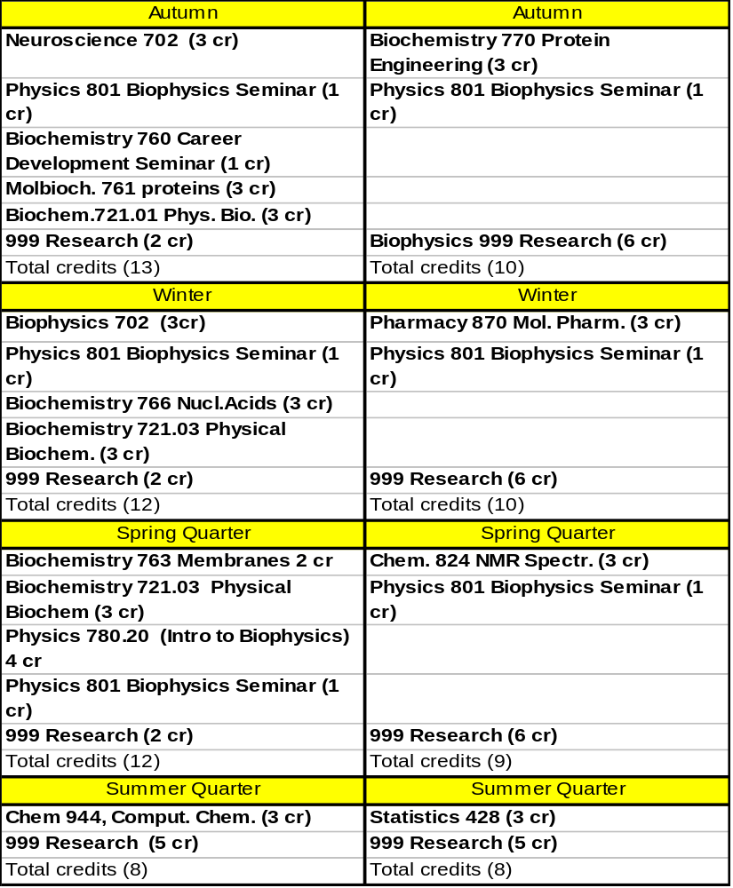

Note: the total graded credits in Year 1 = 28 credits, 25 could be considered “Foundation Courses”, of which 17 are required in the first year. Total Credits in Structural Biology & Molecular Biophysics “Core” Curriculum, beyond the 20 hours of “foundation courses” = 19 credits (minimum of 12 required before Qualifying Exam) with request for Stats 428 accepted by the Grad Committee.
B. Cellular and Integrative Biophysics Track (CIB)

Students specializing in Cellular and Integrative Biophysics must acquire significant knowledge in biochemistry, integrated life sciences and increasingly, molecular biology. Depending upon the student’s goals, expertise in life sciences can include areas such as cell biology, plant physiology/biochemistry, microbiology, and immunology. The following objectives should be met through formal course work, approved previous undergraduate course work, or through informal mechanisms, as may be recommended by the student’s advisor, advisory committee, or by the Graduate Studies Committee.

Objectives for acquiring a general background

- Solid background in basic graduate level biochemistry and physical biochemistry. This requirement may be fulfilled in various ways, depending upon the student’s previous experience in the area. For many students, a background in basic biochemistry may be obtained with the Biochemistry 511 course. This is an extremely intense (5 cr) summary of biochemistry that includes most important areas, including metabolism and some molecular biology. It is offered all four quarters and can be taken in the summer, prior to the first fall quarter of enrollment. Those with a good background in chemistry might consider taking Biochemistry 613 and 614 as a good option, or Chemistry 661.01 and 661.02. These courses generally require organic chemistry as a prerequisite, which can be taken or audited during the summer preceding year one (e.g., Organic Chemistry 253). For those with an extensive undergraduate biochemistry background, a higher level course might be a suitable substitute, such as Metabolic Integration (Molecular and Cellular Biochemistry 764), or Membranes and Bioenergetics (Chemistry 763). Both are taught during the spring quarter.

- Solid background in physical chemistry and/or biochemistry
Much of a traditional biophysics curriculum includes physical biochemistry and some aspects of physical biochemistry, such as an understanding of thermodynamics, diffusion, and kinetics. These topics are critically important for understanding organisms at a physiological level. It is highly recommended that students entering this track take Biochemistry 721.01 (Thermodynamics) and 721.03 (Kinetics, diffusion, etc.). Students with extensive physics and physical chemistry backgrounds as undergraduates may be able to skip these courses. In addition, alternative physical chemistry courses are available in the Department of Chemistry , such as Chemistry 881, Physical Chemistry. This course has a very good reputation among students (winter quarter).

- Solid background in basic graduate level molecular biology. As integrative and cellular biology advance, one of the chief tools for manipulating physiologic systems is to work with genetically altered strains. A good basic background in molecular biology is, therefore, important for long-term success. This can be obtained by completion of beginning-level courses in biochemistry such as Biochemistry 614 and 615 or can be supplemented by one Biochemistry 702, Molecular genetics and Gene transcription (spring), or by more advanced courses, such as Molecular Genetics I and II 605 and 606.

- Solid background in basic graduate level physiology, cell biology, or equivalent. Physiology 601 and 602 is the beginning sequence for graduate students who wish to work in physiological aspects of biophysics in animals. Both are intense five credit courses; 601 covers most biophysical properties of membranes, nerves, muscle, etc. and 602 covers more integrative organ-systems physiology. For students interested in going into plant physiology, the Plant Biology 630 and 631 series is recommended. For microbiology/immunology, Microbiology 520 and 521 or Medical Microbiology 625 and 626 are recommended. Students specifically interested in cell biology can consider taking Cell Biology 607, as well.

- Hands on chemistry/biochemistry laboratory experience. In most laboratories working in cellular or integrative biophysics, there is always considerable basic biochemistry going on that requires students to have good laboratory practice procedures to utilize pipettes, weigh and measure samples, work with antibodies, isolate proteins or RNA, use RNAi or PCR techniques, etc. This requirement can be met by extensive laboratory experience if the student has spent extended time in laboratories or from coursework. One general laboratory course is Biochemistry 521 (available all quarters). This is an introductory laboratory course provides fundamental experience for those with little background. Biochemistry 706 (Protein, enzyme, molecular biology laboratory, 5 cr hr, fall quarter) is a much more extensive course, but is highly recommended and may be appropriate for specific students.

4. Statistics and Bioinformatics. A working capacity in these subjects is increasingly necessary to pursue research activities in biophysics. The introductory sequence, Statistics 520 and 521, is highly recommended. Biostatistics B318 or Statistics 427 may be suitable for some students without advanced needs. With regard to bioinformatics, the winter quarter Biophysics 702 and Physics 780 (spring quarter) should be sufficient for most students. However, Microbiology H610 (Bioinformatics and Molecular Biology) is highly recommended as a general introduction.

Development of a refined background in cellular and integrative biophysics

Advanced and specialized course work may be used to tailor the student’s background to specific interests and research activities. The following list enumerates some of the courses that are recommended, as appropriate for your career direction. However, it is far from comprehensive. Be sure to work closely with your advisor, mentor, and other faculty members to specialize your curriculum as your career progresses.

1. Biochemistry and Molecular Biophysics
Molecular and Cellular Biochemistry 761, Proteins
Biochemistry 765 series, Physical Biochemistry 721.01, 721.02, 721.03 series.
Molecular and Cellular Biochemistry (MCB) 762, Enzyme kinetics
MCB 824, Enzymology
MCB 764, Metabolic Integration
Chemistry 763, Membranes and Bioenergetics
Physics 880.20 Special Topics in Biophysics (largely topics of molecular spectroscopy)

2. Molecular Biology
Molecular Genetics 605 and 606
Biochemistry 702, Regulation of Gene Expression
Biochemistry 766, Nucleic Acids
MCB 831, Eukaryotic Genome
MCB 785 DNA Microarray Technology
Plant Pathology 703, Agricultural Genomics

- Physiology/Cell Biology
Animal or Organ System Physiology emphasis
Physiology 795, Special Topics (when offered)
Molecular Genetics 705, Advances in Cell Biology
Specialized Courses in Veterinary Biosciences Depending on areas of interest; e.g. 610, 700, 750, 790, 792, 803. Note that most of these are at a whole organ level of integration and should be chosen with consultation.
Neuroscience 723, 724 (Molecular and Cellular Neurobiology and Neurophysiology)
Note: many other neuroscience courses are available if you work in that area.
MCB 781 Animal models of human disease (transgenic/knockout models, etc.)
Biomedical Engineering 701, Survey of Cardiovascular Bioengineering
Biomedical Engineering 732, Soft Tissue Biomaterials

- Physiological Modeling and Integration
Mathematics 865 Courses are occasionally offered on modeling cell systems,Calcium signaling, or neural function.
Physics 880.20 (Statistical Physics, 846, 847)
Electrical Engineering 650, Introduction to Estimation, experience in using MATLAB

5. Other Areas
Chemistry 673, Introduction to Quantum Chemistry and Spectroscopy
Chemistry 866, Analytical Spectroscopy
Biomedical Engineering 721, Biological Transport
Plant Biology 630 and 631, Plant Physiology
Medical Microbiology 625
MIVEMG 804, Immunology
Electrical Engineering 557, Controls, Signals and Systems Laboratory
Physics 617. Electronics for Physicists (good laboratory for developing skills with instrumentation).

Typical curriculum plans for the first two years (CIB Track)

The sample curriculum shown below would be appropriate for someone having an undergraduate background in chemistry, physical chemistry, and biology, but not in physiology, and who intends to undertake their thesis work in cellular and integrative biophysics. Many variants of this are possible, depending upon the interests of the student and the recommendations of the student’s thesis advisor and advisory committee. Note that this example student had no formal teaching assignments. Ask for advice from your advisor or the Program Director regarding the difficulty of the combined course schedule.

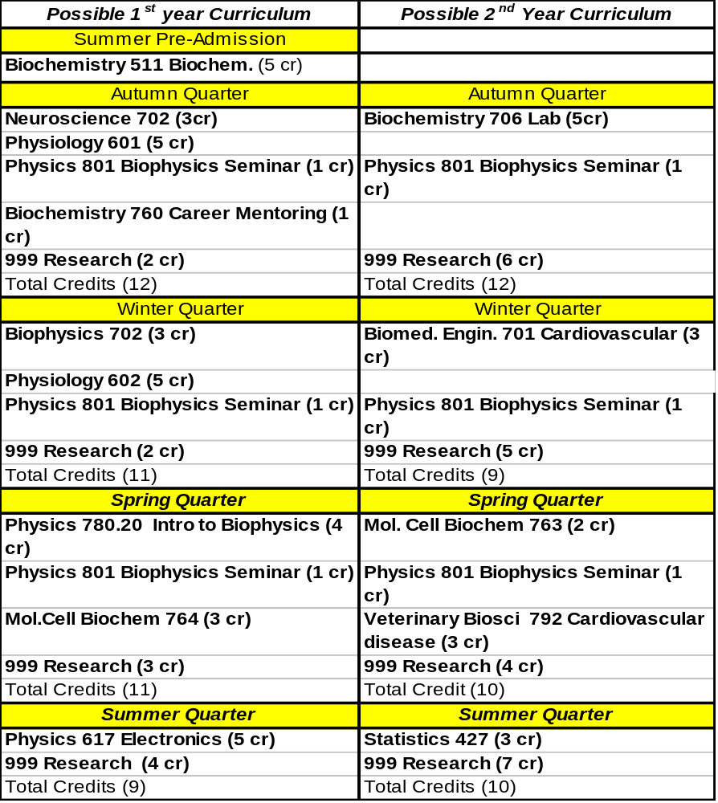Note: the total graded credits in Year 1 = 30 credits (including pre-summer); 26 could be considered “foundation courses” (minimum of 17 required in the first year). Total Credits in the CIB track “Core” Curriculum, beyond the 20 hours of foundation courses = 24 credits (minimum of 12 required before Qualifying Exam) with request for Statistics 427 accepted by the Graduate Studies Committee for graduate credit.
C. Biological Imaging and Spectroscopy Track (BIS)

Students specializing in the Biological Imaging and Spectroscopy Tract will be engaged in research utilizing high-end imaging technology for medical diagnostic or basic research applications (e.g., MRI, EPR, PET, CT, Ultrasound, multiphoton, and confocal imaging), and/or research using spectroscopic techniques for assessment of chemical and biological processes and structures (NMR, EPR, light/laser spectroscopy, electron microscopy, Raman, and x-ray spectroscopy, optics, fluorescent detection, magnetic force microscopy, etc).

As such, students specializing in this tract must acquire a solid background and advanced knowledge in the physics and engineering of the specific imaging/spectroscopy modality they are working in, as well as good background in the structural and functional (physiologic) mechanisms to the studied.

Objectives for acquiring a general background

1. Solid background in life sciences.
Objectives: Incoming students with physical science and/or engineering backgrounds will have to substantially expand their knowledge of biological and life sciences. While imaging and spectroscopy research will have a very strong component ofcomplex technology, it is mandatory for the successful researcher to have extensive knowledge of the biological and medical background, as well.For example, in medical imaging, this includes basic knowledge of anatomy, which may be acquired through self-study and interdisciplinary research collaboration. With the progressive development of imaging applications beyond mere structural, toward functional assessment, it is necessary for students to acquire some fundamental knowledge in biochemistry and physiology. Examples are neuro-functional MRI, requiring knowledge of neurophysiology and behavioral science, dynamic contrast-enhanced MRI or PET, requiring knowledge in normal and abnormal tissue perfusion and pharmacokinetics, and EPR, requiring knowledge of free radial biology, etc. Some courses which could provide a minimum background in these areas include Biochemistry 511 (taught all four quarters) and Physiology 601/602. There are also higher levels of these series available.
For students working in areas of advanced imaging methodology at a cellular level, these same basic biochemistry and physiology courses will also be useful. A cellular biology course (e.g. Molecular Genetics 607, Cell biology, and Microbiology 655, Animal cell culture techniques) may be applicable, as well. For individuals interested in working in other systems, such as plants or micro-organisms, equivalent courses are available in several departments.

2. Solid background in physical sciences and math
Objectives: Especially applicable to incoming biology, biochemistry, and chemistry majors, it may be necessary to acquire additional training in physics, mathematics, and engineering, to acquire expertise in advanced imaging and spectroscopy technology. As most modern imaging and spectroscopy equipment is computer-controlled, and since the complexity of collected data requires computer-based analysis, students will have to gain experience with computer programming. Some courses that could be used to meet these objectives include: Linear Algebra: Mathematics 568 and 569, Introductory linear algebra, or Math 601, 602, and 603, Mathematical principles in science I-III A working knowledge of linear algebra and its application is essential for all aspects of imaging technology. Physics, including quantum mechanics, fields and waves: Chemistry 673, Introduction to quantum chemistry and spectroscopy, or Physics 631-633, Introductory quantum mechanics, Physics 555, 656, 657, through Fields and Waves. Computer Graphics and Signal Processing: Development of good programming skills in a modern language. Electrical Engineering (EE) 600, Introduction to digital signal processing and Computer Science and Engineering (CSE) 681, Introduction to computer graphics. Both courses have associated laboratory courses.

3. Statistics:
Objective: A graduate level background in statistics is absolutely essential. Course that can meet this requirement are Statistics 520 and 521, Mathematical statistics, although a number of other courses are also available.

4. Basic knowledge in specific areas of biological imaging and spectroscopy.
Objective: Students will be required to take some background class work to gain minimum expertise in their specific imaging or spectroscopy modality. It is also highly recommended that students acquire knowledge of alternate, complementarily, or competing modalities. Formal courses are currently not available for all imaging and spectroscopy modalities, although there are a number of new courses and course structures in this area currently under development. As an alternative, it is recommended to take formal independent studies or courses with similar context under specific advisors. Some courses student may consider to meet this requirement include:MRI:
Radiology/BME 813 and 814, Advanced magnetic resonance imaging and spectroscopy.

NMR:
Physics 880.20, Special topics in modern Biophysics. Chemistry 632, Spectroscopic methods in organic chemistry.
Chemistry 866, Electronic spectra and structure of molecules.
Chemistry 824, Nuclear magnetic resonance spectroscopy.

Other imaging /Spectroscopy modalities
Electrical Engineering 706, Medical imaging.
Biomedical Engineering 686, Introduction to biomedical ultrasound .
Biomedical Engineering 611, Fundamentals of biomedical microscopic imaging.
Electrical Engineering 716, Optics with laser light.
Electrical Engineering 732, Quantum electro devices.
Chemistry 823, Analytic spectroscopy.
Chemistry 866, Electronic spectra and structure of molecules.
Biomedical Engineering 990, Optical techniques.

Development of a refined background in Biological Spectroscopy and Imaging (BIS).

1. Laboratory Courses:
Wet-lab work does not constitute a major part of the research in which students in this track may be involved. Thus, this tract does not necessarily require wet biology laboratory courses. Exposure and experience gained during the required initial laboratory rotations and in the imaging/spectroscopy research laboratory are likely sufficient. If applicable, additional laboratories related to working with advanced instrumentation may be useful and gained through courses, such as:
- Formalized independent study.
- Computer labs (note that several ECE and CSE course include computer lab components).
- Options from existing laboratory courses: Physics 616, Advanced physics laboratory; Physics 617, Electronics for physicists; Electrical Engineering 517, Electromagnetics laboratory.

6. Advanced Life Science:
Objective: Beyond gaining basic knowledge of biochemistry and physiology, it is required for Biophysics students to learn about the biological, physiological, and medical aspects of their specific areas of research. For example, if imaging research is neuro-imaging, additional background in neuroscience, neuroanatomy, neurology, or behavioral science is required. Likewise, students doing research in cardiac imaging or spectroscopy, oncology, development of contrast agents, or structural biology need to acquire knowledge in their respective areas. This may be accomplished by self-study under the guidance of the Advisor and Candidacy Exam Committee or through formal course work.

Suggested courses meeting these objectives are
Neuro Imaging:
- Psychology 806*, 807*, 808* Neurophysiology 1-3.
- Veterinary Biosciences 700 and 701, Applied functional neuroanatomy.
- Neuroscience 716, Human neurobiology.
- Neuroscience 723, Cellular and molecular neurobiology.
- Neuroscience 724, Neurophysiology
Cardiac Imaging:
- Veterinary Biosciences 790*, Comparative cardiac physiology.
- Veterinary Biosciences 791*, Heart sounds and murmurs.
- Veterinary Biosciences 792*, Signs, symptoms, and treatment of cardiac physiology
Ocology:
- Veterinary Biosciences 640, Fundaments of oncology.
- Radiology 670, Medical Radiation Physics.
- Radiology 680, Radiation Biology.
Anatomy/Pathology:
- Anatomy 700, Human histology.
Radiology (to be announced) Pharmacy/Pharmacology:
- Pharmacy 616, Medical applications of radionuclides and radiopharmaceuticals.
- Pharmacy 735, Drug discovery and drug design.
- Pharmacy 800, Radioisotope tracer techniques and radiopharmaceuticals.
- Pharmacy 802, Pharmacokinetics.
Genetics:
- Molecular Biotechnology 733, Human genetics.
- Molecular Biotechnology 781, Animal models of human disease.
- Molecular Genetics 500, General genetics.
- Molecular Genetics 605 and 604, Molecular genetics.
- Molecular Genetics 607, Cell biology.
- Molecular Genetics 733, Human genetics.
- Biochemistry 702, Molecular genetics.

7. Advanced Imaging Technology
Objective: In addition to acquiring basic and advanced knowledge in a specific imaging or spectroscopy modality, students are strongly encouraged to take general courses in image acquisition and analysis, and/or technical methodology for specific imaging or spectroscopy modalities.

Courses that can be used to meet these objectives include:
- ECE 706, Introduction to medical imaging.
- ECE 700, Digital signal processing.
- ECE 707, Digital image processing.
- ECE 711, Radiation from antennas (for MRI and EPR students).
- ECE 719, Electromagnetic Field Theory (for MRI and EPR students).
- ECE 863, Computer vision.
- CSE 781, Introduction to 3D image generation.
- CSE 782, Advanced 3D image generation.
- CSE 784, Geometric modeling.
- IBGP 730, 731, Biomedical informatics.

Additional Statistical Background
Statistics 641, Design and analysis of experiments. Statistics 645, Applied regression analysis, or Biostatistics 615, Design and analysis of clinical trials.

An interdisciplinary graduate specialization in biomedical image acquisition, processing and data management has been developed as part of an NIH award, involving the OSU Departments of Bioinformatics, Radiology, Electrical & Computer Engineering, Computer Science and Engineering, the Davis Heart & Lung Research Institute, and the Biophysics Program. Recommended courses for this specialization include the courses listed here in sections 4 and 7. Participation in this specialization (equivalent to a PhD level minor, requiring 12 credit hours) is highly recommended. Contact the Biophysics Program Director or the Director of the BIS Division for more information.

Typical Curriculum plan for a student in the BIS track

The sample curriculum shown below would be appropriate for someone with a strong physics/biophysics/mathematics undergraduate curriculum who wishes to work in areas related to magnetic resonance imaging. Different courses would be recommended for students with other backgrounds, so use this as simply an example and not a specific set of requirements.

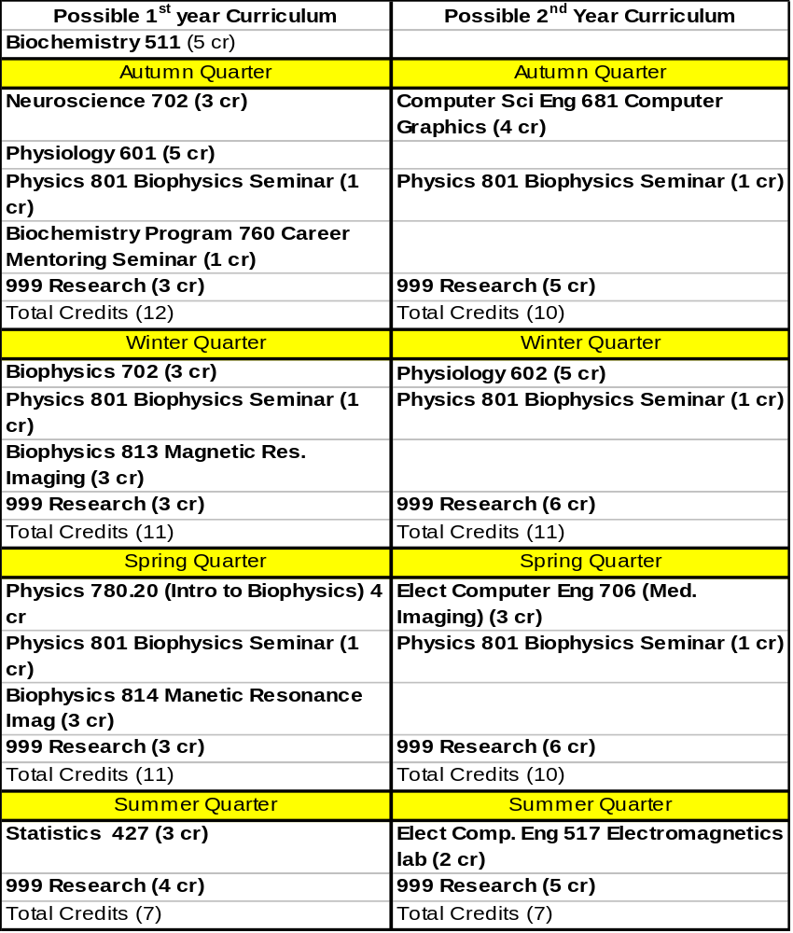
Note: the total graded credits in Year 1 = 29 credits, 26 could be considered “Foundation Courses” (minimum of 17 required in the first year. Total Credits in the BIS track “Core” Curriculum, beyond the 20 hours of foundation courses = 22 credits (minimum of 12 required before Qualifying Exam) with request for Statistics 427 accepted by the Graduate Studies Committee for graduate credit.
D. Computational Biology and Bioinformatics Track (CBB)

Students specializing in this track should be able to meet the following objectives through graduate coursework, previous undergraduate coursework (approved), or through more informal, but approved mechanisms, such as study groups or independent study under the direction of Biophysics faculty. Because students of bioinformatics and computational biology need specialized training, not only in biology and biochemistry, but also in computer science, mathematics and statistics, it is important that they select their coursework carefully and that they work closely with their advisory committee, advisor and Graduate Studies Committee Chair to design their curriculum. They will generally have a higher course load than students working in other divisions. This division is intended for students who desire to gain sufficient expertise in both biological and computational domains to perform research that bridges these domains. Training programs in this division are extremely rigorous. It is not designed to foster research programs that use the tools of one domain to facilitate research in the other, but rather programs that integrate high-quality research in both domains and that fundamentally advance both biological and computational sciences at the interface. One path to developing this advanced, bifunctional training that has been successful in the past, has been for students to recruit mentors in both the computational and biological domains and to work on a collaborative project between them.

Objectives for acquiring a general background

- Solid background in biochemistry with training in molecular biology and/or molecular genetics. Requirements in these areas can be met in a number of ways. Depending on previous background, students in this track might consider the Biochemistry 511 course, which is a summary course. If coupled with some additional molecular genetics or molecular biology, this may be adequate. However, students interested in computational aspects of protein or nucleic acid structure should consider the protein course Molecular and Cellular Biochemistry 761 (autumn), followed by Biochemistry 766, Nucleic acids (winter). Other options are available. Another good course in Molecular Genetics is Biochemistry 702, Molecular genetics: regulation of gene expression. The Biochemistry 613, 614, 615 series is also acceptable. Students wishing to perform bioinformatics research in a completely divergent domain are encouraged to propose the domain, and a similarly intensive program of study for consideration by the Graduate Studies Committee.
- Hands-on wet lab biology experience. It is extremely valuable for students working in bioinformatics to have some hands-on experience in the biological domain underlying their computational component, in part so that they can communicateeffectively regarding the domain, but also so that they intuitively understand the real challenges and opportunities presented by the domain. Such intuition cannot be acquired from readings or discussion with mentors or colleagues. It can only be acquired through hands-on experience. This can be obtained by direct lab experience or by laboratory coursework but should include exposure to biological techniques appropriate for their proposed course of study, such as RNA or DNA extraction techniques, PCR, microarray technology, and proteomics. For students focusing on genomics, proteomics, or microbial topics, Microbiology 581 is an excellent choice. More advanced students should consider Biochemistry 706 or 710. Biochemistry 708 and 770 are recommended for students interested in protein structure and function.
- To develop a familiarity with fundamental bioinformatic approaches currently available to solve biological problems. Students should be familiar with a variety of techniques that are commonly used in bioinformatics, without necessarily specializing in them. For students unfamiliar with the domain,Microbiology H610, Bioinformatics and molecular biology (fall quarter) is a recommended introduction. In some years, there is a less comprehensive course taught in the Integrated Bioscience Graduate Program IBGP 705, Bioinformatics applied to human disease. IBGP 730 and 731 are recommended for students coming to the program with previous experience with basic bioinformatics tools and techniques.
- Todevelop a familiarity with fundamental computational issues that broadly apply to biological problem domains. It is assumed that students have already acquired some programming experience in a modern language. If not, a course such as one from the CSE 459 series is recommended, though this will not count towards core or fundamental credit hour requirements. It should be stressed that programming and implementation are not fundamental components of successful bioinformatics or computational biology research programs. Students should think of their computational training as an opportunity to learn to design novel solutions to important biological problems, not as an exercise in implementing such solutions. Nonetheless, most successful research programs in this division will require some implementation skills, as few labs have the resources to provide implementation services for student projects. Thus, CSE 560, Systems software design, development, and documentation, is highly recommended for students in the division.
Fundamental computational issues that apply to almost all bioinformatics/computational biology pursuits include data structures (CSE 680), algorithms (CSE 780), computability and unsolvability (CSE 725), computational complexity (CSE 727), numerical methods (CSE 640,642), databases (CSE 670 and 671), and distributed computing (CSE 763). An introduction to formal languages and automata (CSE 625) is recommended for students headed towards some form of sequence analysis project. Students are encouraged to acquire training in as many of these areas as possible, as they are importantly synergistic in enabling computational approaches.
- To develop a solid background in statistics and mathematics. A graduate level background in statistics is essential. A highly recommended statistics series is Statistics 520 and 521, which should be adequate. A mathematics course that is also highly recommended is Mathematics 768, Discrete mathematical models.

Selection of courses and objectives in the following section are designed for refining a career in bioinformatics. The choice of objectives and course work will depend on the advisor, the student’s advisory committee and the general area of research. In general, it is our hope to train students in this area who come with a strong biological background and with quantitative and mathematical skills that are unique among different kinds of students who enter into this field.

Objectives for acquiring a refined background, specializing in two or more areas of bioinformatics.

- Advanced understanding of a complex biological system, such as gene regulation, metabolism, or microbial pathogenesis, . There are a number of advanced courses in gene expression and molecular genetics available. If the student has not had an extensive background, introductory courses that may be added to a general biochemistry curriculum include Biochemistry 702, Molecular genetics: regulation of gene expression, or possibly Molecular Genetics I 605 (winter quarter), Molecular Genetics II 606 (spring quarter) or Molecular and Cellular Biochemistry 831, Eukaryotic genome: structure and expression (winter quarter). Students with research focuses in areas not covered here are encouraged to petition the Graduate Studies Committee to accept alternative, similarly rigorous and fundamental coursework for foundation course hours. Students are also reminded that they are not limited to the core and foundation course hours, and are encouraged to acquire any additional formal training that they and their mentors feel is appropriate.
- Advanced understanding of computational techniques as applied to their biological field of study. This requirement will generally be met by CSE coursework in the 700 and above range. It is too diverse to list specific recommendations, and should be tailored by the student’s mentor and advisory committee to support the student’s overall research program. For example, a student working on analyzing complex microbial colony morphology may well be served by coursework in computer vision and graphics. One concentrating on improving BLAST would be encouraged to pursue additional training in advanced analysis of algorithms and data structures. One modeling complex enzyme kinetics should have additional training in numerical modeling of differential equations. A student involved in improving microarray technology and analysis could profit from both data mining and database topics. A student interested in modeling gene regulation may require additional exposure to formal language techniques.
- Topics related to specific techniques and biological aspects that apply to or require bioinformatics or computational biology. For example, courses are offered in DNA Microarray Technology (Molecular and Cellular Biochemistry 785 (usually spring quarter. Another course that combines genomics, proteomics, and bioinformatics is Plant Pathology 703 - Agricultural genomics: principles and applications. Biochemistry 770, Protein engineering, may be of interest to some students, as well as Chemistry 944, Computational chemistry.

An example curriculum for incoming bioinformatics students:

The example curriculum below is one that might be set up for a student with strong chemistry and physics background with some solid programming experience and no teaching requirements, who came to OSU for pre-enrollment in the summer and took an introductory biochemistry course during that time. Note that this outline would change considerably for students coming from different backgrounds or students going into different kinds of biophysics training. Please note that this plan is not rigid but rather just a description of one possibility, the details of which should be reviewed with the student’s advisor and/or Graduate Studies Committee Chair. Note also that many of the advanced courses require prerequisites that are not listed here. It is sometimes possible to petition out of such prerequisites, if the student has either prior experience or a demonstrated record of mastering advanced topics without formal background training. Students should not automatically expect that entrance requirements will be waived in all cases. However, discussions with instructors about prerequisites should take place early, and course loads should be planned strategically to allow the insertion of prerequisite courses as necessary.
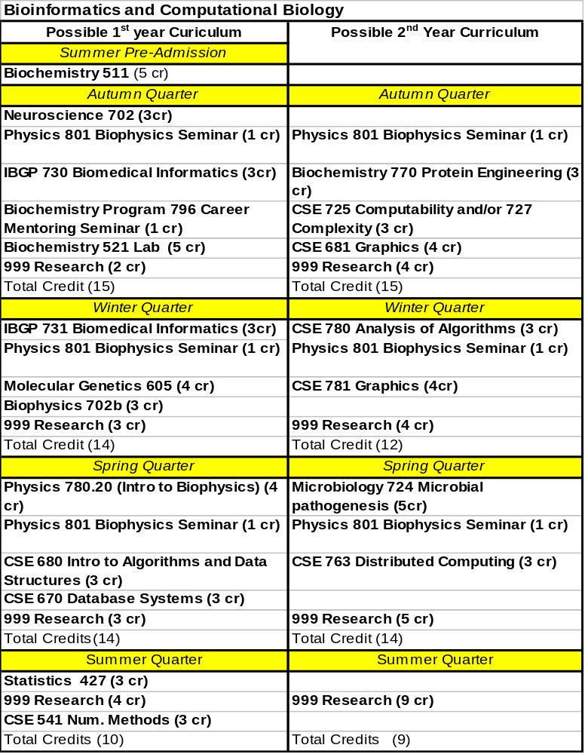

Note: the total graded credits in Year 1 (including pre-summer enrollment) = 33 credits, 27 could be considered “foundation courses” (minimum of 17 required in the first year. Total credits in the BCB track “core” curriculum, beyond the 20 hours of “foundation courses = 15 + additional courses in year 1 could be added over and above the minimum foundation credits (minimum of 12 required before the qualifying exam).

V. General Biophysics Graduate Program Policies

A. Ph.D. Candidates and Financial Aid

The OSU Biophysics Program is a Ph.D. training program. All candidates who expect financial support from the program must be enrolled and be in good standing as Ph.D. candidates. Students who enroll with the desire to attain only an M.S. degree will not be supported on graduate assistantships or fellowships and will not receive fee waivers. Generally, masters degree candidates are self-supporting students. In some cases, students decide to switch to a masters program after beginning a Ph.D. program. In other cases, the Graduate Studies Committee or the students’ advisory committees recommend that they do not continue for a Ph.D. program and can make the opportunity available to them to complete only a masters degree. The Biophysics Program does not promise to support students who decide to complete only a masters degree or who have been fully evaluated as a Ph.D. candidate but their committee does not recommend them to continue for a Ph.D. (see details on this issue in later sections)

Ph.D. candidates are supported in one of three categories, as Graduate Teaching Assistants (GTAs), Graduate Research Assistants (GRAs) or as University Fellows. Fellowships are generally awarded by the University on a competitive basis. The Biophysics Program submits the best incoming candidates for this competition each year. University fellows have no teaching obligations, and much of their support comes from Graduate School funds and there are certain other advantages that differ from GTA and GRA positions, such as tax benefits and stipend levels.

GTAs (or TAs for short) are enrolled with the understanding that they will have some teaching obligations during the school year. These teaching obligations are part-time and are provided by contracts between the Biophysics Program and other undergraduate teaching departments or programs. Although you may be teaching in another department or college, you are still under contract with Biophysics during your TA assignments. Some TA positions are also used to assist the Biophysics Program in carrying out its teaching activities, maintaining its web site, or assisting in other administrative aspects of the education program. Generally, students are asked to teach for only 1-2 quarters in the first year. Students beyond the first year also participate in teaching biochemistry or mathematics at times, depending on their training and the department of their mentor. It is recommended that GTAs ask for specific teaching assignments, but the actual assignment a student is given often depends on other variables related to the budgetary limitations of the programs involved. Note, students who have not passed their English exams cannot teach in the formal undergraduate programs.

GRAs (RAs for short) are usually enrolled in our program with the understanding that they will be working with specific mentors in a specific laboratory. These RA arrangements, for first year students, are generally negotiated independently by the student and the particular mentor during the application process. They are relatively rare in the first year and, for first-year students, are often reserved for highly trained students transferring from other programs that have made contact with faculty in the Biophysics Program. In this case, the mentor is responsible for financial support of the student during the first year.

Many students become RAs after their first year of training and are supported from grants of the principle investigators on the faculty. All students in the laboratories of College of Medicine must be RAs on grants, as there are no teaching positions. However, in several basic science departments such as Mathematics, Biochemistry and Chemistry, TA positions are available and provide support for laboratories that have do not have an available RA position that is funded.

All TAs and RAs are considered 50% FTE (full time equivalent) employees. This is the manner in which such positions are handled in graduate schools across the U.S. This appointment does not mean that the student is required to work only 50% of the time as a TA or RA. It is only a fixed value for the purposes of ensuring that the student is categorized in the work force as a part time, temporary employee pursuing their education (i.e., without full time working benefits). Additional forms of support beyond the 50% GRA salary include tuition and fees and some health insurance, both of which represent a substantial additional investment in each student. The current health insurance and benefit policies for graduate students and their dependents can be found on the Graduate School Website: http://shi.osu.edu/graduate.asp. In 2008-2009, about 80% of the student’s health care will be subsidized by the University.

Every student who is enrolled as a Ph.D. candidate is brought in with the expectation that the program will support him or her throughout their Ph.D. training with financial aid in the form of a TA, RA, or fellowship and with full tuition and fees. The program does everything it can to ensure that students are continuously supported and we have an outstanding track record in that regard. In the past 5-6 years, essentially every student in good standing has been supported fully for their career. However, it is important to understand that this support comes with certain expectations of every student, including 1) successful performance of their studies with an appropriate course load and grade point average, and 2) successful recruitment of a research mentor who can take over for their support throughout the rest of their training. These considerations are part of the concept of being in good standing and are considered the responsibility of the student to fulfill. The Program will do everything it can to provide continuity to student’s training, but it is always a two-way street and requires commitment, assertiveness, and hard work by the student. In fact, this is the nature of science and any creative enterprise. Student support is dependent on performance.

Note that students are not allowed to work in another job while receiving a stipend as a TA, GA, or fellow in the Biophysics Program. It is assumed that students will be using all of the time available for them in preparing for a degree. This applies throughout their degree program as long as they receive financial aid.

B. Masters Degree Candidates

As mentioned, the Biophysics Program does not admit students wishing to pursue only a masters degree, unless they are self-supporting. Students who decide or are no longer eligible to pursue a Ph.D can be supported by individual grants of principal investigators or by teaching assignments arranged by their mentor within the mentor’s home department. This, however, is independent of the Biophysics Program budgetary expenditures. Students on a fellowship who decide to not pursue a Ph.D. degree will immediately lose their fellowship from the University and financial aid from the Biophysics Program. Applicants who wish to only attain a masters degree cannot be submitted for fellowship support and will not be submitted to other programs for TA support within the University.

There are several mechanisms to obtain a masters degree in Biophysics, as follows:

1) Successfully completing the General Qualifying Examination for Ph.D. candidacy. Students who complete this landmark accomplishment are automatically awarded a masters degree (if they wish to receive it). To do so requires only an application to graduate with a masters degree from the Graduate School following completion of the exam.

2) Complete a written experimental masters thesis, complete the necessary number of credit hours with greater than 3.0 GPA, as dictated by the Graduate School (45 hours), and at least 32 graded course credits within the category of foundation courses and core courses, as listed above. In general, the content of a masters thesis must be based on experimental work completed by the applicant. The quantity of work necessary would generally be sufficient for at least one publication in a good scientific journal (note that most Ph.D. theses yield between 3-5 papers or manuscripts). In addition, masters theses generally contain a more extensive background and introductory section than would be submitted for publication as a manuscript. The defense of the masters degree follows the guidelines in the Graduate School Handbook. http://www.gradsch.ohio-state.edu/Faculty/GSpubs/Handbook.html.

3) Complete and successfully pass a modified preliminary examination and complete a “modified” masters thesis. The preliminary exam should be identical to the format for the Ph.D. preliminary exam but questions provided from a minimum of 3 faculty members (note that the Graduate School requires only two committee members for a masters thesis defense, so you must recruit one more for this degree). This mechanism is provided only by special permission of the Biophysics Graduate Studies Committee, is generally discouraged, but is allowed on a case-by-case basis. It is a mechanism devised for students who have had difficulty generating a body of experimental work that could be utilized as a traditional masters thesis but who have had extensive and successful course work in biophysics. Students must complete > 45 total credits with no less than 32 credits of graded courses with an average of greater than 3.0 GPA, in the categories of foundation or core courses. The thesis is composed of an extensive review of a research topic, approved by the student’s mentor, the masters committee (advisor and one other faculty member) and at least one member of the Biophysics Graduate Studies Committee. The content of the thesis review must be sufficient to warrant possible publication as a formal literature review.

C. Laboratory Internships (Rotations)

Students are required to successfully complete at least three internships with Biophysics Program faculty within their first four quarters of support. In general, successful internships last approximately one quarter and these internships also extend into the periods between quarters and during breaks. As mentioned below, graduate students are considered to be on 12-month contracts, independent of the actual school year calendar and therefore their laboratory work and learning are not limited to the time during formal quarter schedules. In fact, the most productive internship periods usually occur between quarters, when both the student and the faculty members have reduced responsibilities outside of the laboratory. Internships can last as little as five weeks, but this is usually reserved for situations where it is clear that the laboratory is not suited to the student or when faculty may be available for only a few weeks because of traveling or responsibilities away from the OSU campus.

The Biophysics Program considers that all students should be engaged in an internship of some kind, throughout their first year of training. It is the student’s responsibility to find suitable faculty to work with. It is extremely important that you keep in mind what the actual purposes of laboratory internships are, as described below.

- The primary purpose of laboratory internships is to find a suitable mentor in your area of interest, who projects that he or she will have funding or available TA positions to support you during your research training. Please note that this is not an easy task. Many faculty are not in a position to take on the responsibilities of having a new student and, therefore, students need to meet frequently with many faculty to determine a laboratory in which they can negotiate a funded position. This may be the single most important activity that you do in your first year. This is not the program’s responsibility. It is your responsibility.
- The secondary purpose of internships is to learn new techniques, to develop laboratory skills, and to begin actively participating in the process of research. At times, very good internships can result in co-authoring publications and/or presentations of research at national or regional meetings.
- A tertiary purpose is to experience how laboratories operate, how successful investigators manage their staff and students, and what types of research or laboratory styles you find yourself enjoying. Some students, for example, find it effective to work in large laboratories with extensive staff and students to interact with, whereas other students thrive in small laboratories, where they may have more intimate scientific interactions with a mentor and one or two others.

Students in the Biophysics Program are recommended to utilize their rotation advisors’ 999 thesis research course number for their research credit hours. The number of credit hours that students utilize for internships depends on the amount of time that they have available during that quarter. There is really little point in signing up for excessive numbers of hours, because research credit is never a limiting factor in your graduation plans. At times, students can get into problems because they have signed up for too much credit over the years, and OSU will no longer provide fee waivers for students who have accumulated too many credit hours in total. In most cases, because students carry a larger academic load during the first few quarters of admission, between 2-5 hours of 999 /quarter are sufficient, with more during the summer sessions. Use these 999 credit hours to ensure that you have sufficient numbers of credits to remain in active status, for your particular category (i.e., this varies if you are a TA or a fellow or if you have a;ready passed the qualifying exam or the pre-qualifying exam). Whenever possible, use the correct call number of the specific instructor with whom you are rotating. If this is not possible, you can sometimes make arrangements with a Program Director or Graduate Studies Committee Chair to use their call numbers until you arrange the appropriate call number for your internship mentor.

What happens if you cannot find a suitable advisor from the > 80 faculty members of the Biophysics Program? First, meet with a Program Director and other faculty to get ideas with respect to whom is doing what, and with whom you might work. Nearly all faculty will give you suggestions based on your interests, skills, and commitment. This is never an easy process and you must work at it. You will not be successful by being passive about this, so it requiring substantial interactions with people to find your scientific home. If you cannot find an advisor within the members of the Biophysics Program, it is acceptable to look outside of the listed faculty to find other investigators on campus who more closely fit your experimental interests. This is often a way the Program finds valuable additional faculty members. However, be sure to do this only with permission of the Program Director, only after you have exhausted all other possibilities within the Program faculty, and the research area you will pursue is still “Biophysics”.

Finally, extended rotations for longer than one quarter in the first year are not recommended. If you have completed three rotations with different faculty and wish to continue with one of them for another quarter, our program will ask that faculty to commit to you and begin supporting you during that time. For University Fellows, we will ask the faculty member to take over the supplement for the University Fellowship support that is usually paid by the Biophysics Program.

D. A few notes about internships

How much time should you be in the laboratory during internships? The amount of time that you spend in the laboratory is not a simple function of the number of 999 research credit hours for which you registered. In general, when you are in an internship you should consider yourself a temporary member of the laboratory, participating in every kind of research experience that you possibly can, while you are there. It is a good idea to essentially “live” in the laboratory when you are not in class; i.e., to make it your home away from home and study there if you find you have nothing to participate in at that time. It is important that you understand that you are being supported by the State of Ohio to participate in the missions of the University, including both teaching and research. You should consider yourself, upon admission, as an “apprentice scientist,” who has a lot to learn, but also has a lot to offer. It is also important to realize that you are being evaluated every time you walk into the laboratory and, as importantly, every minute that you are not there. For example, if the laboratory opens at 7:30 in the morning and that is when research is being done, it is highly recommended that you also are there at 7:30, to the extent that you can fit it into your schedule. Most investigators work much more than 40 hours per week in the U.S., largely because they love the work and there is never enough time to move as quickly as they would like to in science. It requires a very strong work ethic to be successful as a scientific investigator. Be sure to work out with your internship advisor what your schedule will be and when he or she might expect you to be available. Sometimes advisors are not forthcoming about what they expect and you should target your work to greatly exceed their stated or implied expectations.

Internships are generally what the student makes of them. Many times, faculty cannot be available because of other commitments. If a grant is due that month, most faculty are frequently unavailable during that time. However, that does not mean that during that time you can be inactive. Work closely with other laboratory personnel and make yourself available to help them. For example, you might wash glassware, even when not asked. These things make important impressions on faculty and staff. Spend a great deal of time both before and during the internship, reading the publications of the mentor and any papers or reviews that he or she gives you. Be sure to ask questions of what you do not understand. Keep an active laboratory notebook of your results, your ideas and your growth in that laboratory, to share with the faculty member. Faculty members are looking for students who are self-reliant, who have an inherent interest in many areas of science, and who contribute unselfishly to the intellectual and practical aspects of the research program. Also, they are looking for individuals who they and their staff can work with closely and who will be productive over a number of years. If possible, try to carve out a small project that you can perform independently and that you can complete to make a final report. These small projects can be extremely important for your relationship with the advisor and your general feelings of satisfaction in research. Attend all laboratory meetings that you can and actively participate and ask questions. Volunteer to present a research paper or your results to the group and do so in a professional way. Again, you are being evaluated as to whether you should be invested in and how professional you are, so put your best foot forward and actively participate to the extent of your abilities.

E. Internship Final Report Form

An “Internship Final Report Form” (Apppendix C) should be completed for each internship. Some aspects of this form should be completed prior to doing the internship so that both the student and instructor agree on what is to be accomplished during the internship period. After completion of the internship, with signatures from both faculty and student, submit a copy of the form for your file to the Program Administrator’s office. These forms will be evaluated by the Program Director or Graduate Studies Committee Chair during the year and then distributed to your advisory committee prior to taking your qualifying exam. To receive credit for the three required rotations, you must have a minimum of three internship forms in your file by the end of the first year. Note that many students perform four or five internships and each of these internships should result in a completed form in your student file.

F. Choosing an Advisor/ being Chosen by an Advisor

Your internships have been successful if you have found an advisor who takes responsibility for you by the beginning of the summer term of your first year, or earlier. Students need to arrange to be in laboratories at, and preferably before, that time. The choosing of an advisor is a bit like courtship; it requires both parties to be interested and committed. Once an advisor invites you to join his/her lab, it is important that you discuss issues of salary and how tuition and fees are to be paid. In general, we ask the advisors to support you at the level you were supported in your first year, but sometimes this is not possible and it is important that you discuss this so there is no misunderstanding. One reason that an advisor may pay you more or less than what you are accustomed to is because other students in the laboratory, possibly from other programs, may be paid at different rates. Generally, advisors try to keep stipends of graduate students equitable between lab mates and there is much variation in levels of support between different graduate programs at OSU. Once the advisor has agreed to take you on as a student, ask him or her to fill out the necessary paperwork using the form: “Agreement to become the Ph.D. Advisor for a Biophysics Graduate Student” which is included in Appendix I. It is an implicit assumption that from this point on, he or she will find a means to support you in your graduate work towards a Ph.D. along with your tuition and fees, as long as you are in good standing in his or her laboratory.

G. When the Advisor/Student Relationship Does Not Work Out

Sometimes, personalities clash, goals change or faculty leave for other institutions which makes it impossible for students to continue within the Ph.D. advisor’s laboratory. Under these conditions, it is essential that the student and the faculty member contact a Program Director as soon as possible. The Director will then make an evaluation of the situation by interviewing both the student and advisor and make a determination of what to do next. If it is determined that the student’s performance and commitment are clearly lacking, then the situation will be brought before the Graduate Studies Committee and the student may be dismissed or put on “Program Probation” (discussed below). If it is clear that the student has put forth sufficient effort and acted with integrity, every effort will be made to provide the student the opportunity to find another advisor. However, it is important to realize that the Biophysics Program budget has sufficient funds for only first year students. Therefore, support needed during the interim period to intern in a new faculty’s lab may or may not be available at that time. The program will do everything possible to help the deserving student make the transition without undue financial burden, but this cannot be guaranteed and it is handled on a case-by-case basis.

Experience has taught us that if there is an incompatibility between the student and the advisor it almost always involves the level of effort and commitment to science or work ethic exhibited by the student during the time in the laboratory. It simply becomes a matter of lost resources from the perception of the advisor; i.e., the student does not show enough promise or willingness to work for the advisor to continue to invest in him or her for an extended period. Again, it is important to understand that much is expected of you, as a student, and that you are being evaluated every time you step into the laboratory, every time you ask a question and every time you are late upon arriving in the lab, you miss an appointment or are absent from lab meetings. You are being evaluated by other laboratory personnel as well, such as technicians, postdocs and other senior students. Science requires a great deal of discipline and sacrifice to be successful. The outcome can be incredibly rewarding and it can result in having the most interesting and exciting life of discovery you can imagine. However, it takes hard work, dedication, determination, and professionalism to succeed. Passive, non-creative, or non-energetic behavior from students is generally a sign that students will not be successful in science and faculty will respond to those signals. It is important to remember that it is an incredible honor to have the State of Ohio and the University invest in your future; they continue to invest in you because they believe you will contribute to the OSU legacy and contribute to the overall missions of the University. You have to continually prove that it was a wise investment.

H. Vacation Policy

Beyond the first year of training, you are basically employed as a part-time assistant to a specific laboratory and advisor. It is up to your advisor to determine a vacation policy for you. However, unless he or she specifically states it, you can assume that the policy is the same as for first year students in the Biophysics Program.

The University has specific guidelines for students regarding short term absences and leaves of absence from the University. Please refer to the website http://www.gradsch.ohio-state.edu/Current_Students/Benefits.html. These guidelines are helpful for understanding University policy for needed time off for illness or emergencies during the academic quarters when class is in session. They do not cover program or University policy for time off between quarters. The Biophysics Program has developed its own standards (discussed below), which are in compliance with University guidelines and take precedence over consideration of the entire school year.

First Year Vacation Policy: Students in Biophysics are on a 12-month contract. We expect first year students to limit their time away from campus for purposes of vacation to a maximum of three weeks (15 working days) per year. This does not include official University holidays and does not include sick days or family emergencies, etc., which fall under the short-term absences guidelines of the University. Students do not get breaks between quarters that are traditional for undergraduate students. You are now professionals and contributing to the mission of the University on a 12-month basis. Some students who have not worked in the U.S. have difficulty understanding this policy because many other countries enjoy extended time off in their working environment. The U.S. has a very strong work ethic. By contrast, new public employees of the University have a maximum of ten working days per year for vacation, but build more vacation days slowly, the longer they work. Faculty on twelve-month contracts generally have a maximum of about one month of vacation per year but few take that much.

All students taking time away from their expected activities as a graduate student (at times other than official holidays) must fill out a “Request for Leave Form-Funded Graduate Students”, which can be found in Appendix H. It is essentially the same as that on the Graduate School Website http://www.gradsch.ohio-state.edu/Current_Students/Benefits.html but the Program form includes contact information while you are gone. These forms should be turned in to the Program Administrator who will get approval, keep a record of them and return the form to you.

If for some reason you feel it necessary to take longer periods than three weeks per year of vacation time (e.g., if you are traveling back to your home country to get married, or for some other important family event), you can have the option of taking a leave of absence without pay if you have permission of the Program Director and/or your advisor. Contact the Program Administrator for information regarding that possibility. If you are a University Fellow, you must also get permission from the Graduate School.

It is important to understand that you are not strictly required to come to campus at specific times each day and “clock in.” You are an academic scholar and expected to have considerable freedom and an inner need to be responsible. You are encouraged to work at home or in other places if you can be more productive in writing or preparing for tests, etc. However, make sure you keep in contact with your advisor and that he or she agrees with your plan. Also, make sure that your work ethic carries over into other environments outside the laboratory. Discipline yourself to use your time wisely in all settings.

If you do leave campus for any reason, it is important to inform the Program Administrator where you are going and when you plan on being back and to provide a contact number so that you can be reached quickly. This is included in the form in Appendix H. Failure to do so could have consequences for the Program, your visa status (if this applies), and your academic status. Many times, students left campus with unfinished business, such as missing TA exam grades, unfinished laboratory activities, or papers that were due, and the Program must be able to contact you quickly to resolve the problem.

Lastly, it is not a good idea to save your vacation time in the first year (when you are supported by the program) and use it in the next year, when you are supported by an advisor. If you want to get off to a bad start with your advisor, just take three weeks of vacation immediately upon joining the lab when he or she is paying for it. This is not a good idea. Consider it like a new job after the second year. Take your vacation time in the first year, when it is given to you and then renegotiate this with your advisor once you enter the laboratory.

I. Program Probation, Graduate School Probation and Dismissal

There are several ways that students can fall out of “good standing” in the program and in the Graduate School. Most importantly, the Graduate School will put students on probation if their grade point average (GPA) falls below 3.0, after they have been enrolled for 15 credit hours. A warning is written to you from the Graduate School that explains that if you do not bring your GPA above 3.0 by the next quarter you will be dismissed by the University. Being dismissed from the University for this will preclude you from continuing your graduate education at OSU in any program.

The Biophysics Program has its own probationary status which is more stringent than University Probation. You can fall into Program Probation for the following reasons 1) You are on Graduate School probation or you GPA has fallen below 3.0 for any reason, 2) You take insufficient credit hours of “foundation” courses or “core” courses that do not warrant a full-time status as a serious graduate student at a given level of training. In other words, you are not on track for Ph.D. candidacy for your year of enrollment. 3) Ethical misconduct or inappropriate conduct, which includes any form of plagiarism, falsification of data, or misrepresentation of intellectual property. Unethical behavior can also be grounds for immediate dismissal from the program. Inappropriate conduct can include behavior resulting in arrest, sexual misconduct, sexual harassment, unexcused absence from the University, or other activities considered incompatible with achieving a graduate degree, as deemed applicable by the Biophysics Graduate Studies Committee. 4) Failure to find a suitable mentor within your first year of training. 5) Delaying your qualifying exam beyond the third year of enrollment and 6) Unnecessary delay of your thesis work or defense. If you are put on Program Probation, you will receive a formal letter of your probationary status from the Director(s), which will include what changes will be required for you to regain “good standing” in the program. A letter is put in your permanent file and a copy is sent to the Graduate School. In general, you will be given a certain timeframe to respond (usually one quarter) and failure to do so will result in dismissal from the Program.

J. Ethical and Scientific Misconduct

It is the student’s responsibility to become completely familiar with standards of scientific and academic conduct which have been set forth by the University and are generally held by all academic institutions world-wide. You can find the University’s standards for the student code of ethics on the web page http://studentaffairs.osu.edu/resource_csc.asp.

Of particular concern is the problem of plagiarism. Please note the definition of plagiarism, as outlined by the OSU Code of Student Conduct. “Submitting plagiarized work for an academic requirement. Plagiarism is the representation of another's work or ideas as one's own; it includes the unacknowledged word-for-word use and/or paraphrasing of another person's work, and/or the inappropriate unacknowledged use of another person's ideas.” It is extremely important to understand that plagiarism is not tolerated at any level of performance, including answers to test questions, slide presentations, or written work of any kind. For example, directly quoting handouts that are remembered from memory in the process of answering an exam question is a direct form of plagiarism. If you quote another source, you must put it in quotes and reference the source. Another common problem is information taken from the Internet. Unless you know and can refer to the source and quote the information, you cannot use it appropriately in any kind of assignment or work you are doing for the University.

Any form of scientific or academic misconduct observed by a faculty member can result in immediate dismissal from the Program and the University. For minor infractions an “E” in the assignment, an “E” in the course, or placement on Program Probation may be the consequence. Incidents and appeals of misconduct will be handled by a convened Ethics Subcommittee of the Biophysics Program and/or by the Graduate School Committee on Scientific Misconduct.

K. Transfer from and Dismissal from the Program

The Biophysics Program strongly discourages students from transferring from other programs at OSU into Biophysics or out of Biophysics to other OSU programs or programs at other institutions. Such actions should not be done without careful discussion with the Director(s) of all programs and advisors involved. When considering transfer, students should realize that their home program has invested heavily in their education. The success of bringing qualified students who have matriculated to the Program to complete a Ph.D. degree is evaluated by the University for future budget considerations. For example, if one student transfers out after the first year, there is a loss of ~10% of the total budget from our program, with nothing to show for it. Sometimes, though rarely, it is appropriate to transfer, but this should be considered carefully. The Biophysics curriculum is flexible enough and its policy with regard to mentorship flexible enough to meet the needs of most students whose interests change over time. Therefore, it is important to stay in contact with the Director(s) and members of the Graduate Studies Committee to determine your best career path, if you consider a transfer. Students who apply for and decide to transfer to other universities or graduate programs after enrollment will be immediately dropped from support by the program at any time during the school year. University Fellows who decide to complete only a masters degree, will be dropped from support by the program and by the University. Fellowship support is reserved only for students serious about completing a Ph.D. degree at The Ohio State University.

In rare occasions, such as in response to misconduct, students can be dismissed immediately from the Program. In most cases, however, students are given a reasonable chance to recover when things do not go well by being placed on Program Probation. There are also a number of intermediate actions that can be precipitated by poor student performance such as withdrawing or reducing financial support, making it possible to complete a masters degree without going on to a Ph.D. ( “Terminal Masters”) and doing additional remedial activities that are designed to provide further instruction and background in the areas of deficiency or poor performance. These outcomes will be determined by the Graduate Studies Committee with the possibility of appeal to the Ethics Subcommittee of the Biophysics Program.

L. Biophysics Student Association

Each year the student body will elect the members of the Biophysics Student Association. All representatives but the first year representative will be elected by the end of September; the first year class will elect a first year representative by the end of October.

The activities of the Student Association will be to:
- Organize and coordinate the annual symposium, contact the speakers, events, etc.
- Organize social events for Biophysics students throughout the year and manage a budget to carry out these activities.
- Organize welcoming activities for visiting students and professors.
- Provide input and suggestions to the Graduate Studies Committee for the operations, curriculum and policies of the Biophysics Program.
- The President of the Biophysics Student Association will sit as a formal voting member of the Biophysics Graduate Studies Committee.
- Nominate and oversee the election of the Elizabeth Gross Biophysics Award and other faculty awards.
- Elect and provide Biophysics representation on the OSU Graduate Student Association and to communicate the activities of this association and of the Graduate Studies Committee to the students.

The members of the Biophysics Student Association will be made up of:
- 1 member of the first year student class
- 1 member of the second year student class
- 2 members of the classes third year and up
- 1 elected president (elected program wide). A Vice President, Secretary and Social Chairman will be elected within the Biophysics Student Association members.

The Elizabeth Gross Biophysics Award will be awarded annually by the Biophysics Student Association, with input from all of the Biophysics student body. The award is given to a faculty member In Biophysics who has contributed significantly in one or more of three categories: 1) outstanding biophysics research, 2) outstanding teacher in biophysics and 3) dedication to the success and administrative operations of the Biophysics Program.

The president of the Biophysics Student Association is automatically the president for the university-backed student organization called “Biophysics Organization”. The treasurer and secretary for the Biophysics Organization are selected by the president from among the members of the student government, and their responsibilities are outlined in the organization’s constitution.

VII. Examination Policies:

A. General Overview

Following approximately seven quarters of enrollment students, will begin the process of qualifying examinations. There are three parts to the qualifying examination, the Preliminary Exam, the Written Qualifying Examination and the Oral Qualifying Examination. As the name implies, passing this series of examinations is a prerequisite to continuing toward a Ph.D. degree. The Preliminary Exam will be performed separately from the Written and Oral Qualifying Exam. The Preliminary Exam will be given to all students at the end of their seventh quarter of enrollment. Failure to take the exam by the ninth quarter will result in loss of good standing status and the student will be placed on Program probation. In general, all students will be asked to formulate a committee at the beginning of their second year and the exam will be given during the eighth quarter of enrollment (end of the second year). Students who fail this examination will not be allowed to continue their Ph.D. candidacy.

After passing the Ph.D. qualifying exams and completing the research thesis, students will have a final oral examination/ thesis defense.

The guidelines for all examinations follow those of the Graduate School. Students and faculty should follow those guidelines regarding the underlying rules; see http://www.gradsch.ohio-state.edu/Faculty/GSpubs/Handbook.html. Additional rules and guidelines that are unique to our Program are listed below.

B. The Biophysics Contract:

Because biophysics is such a broad topic, it is essential that some limits be placed on what the exam will cover and also to provide guidance for more refined course selections. To accomplish this, a contract is formed between each faculty member of the qualifying examination committee and the student. This should be completed, early in the second year of enrollment, after selection of a mentor and the remaining advisory committee members. A blank set of forms for a formal contract is included at the end of this document (Appendix D). The contract protects the student from unrealistic expectations of the faculty who are not fully aware of the specific areas of training the students have undertaken in their first and second years.

For the purposes of the Preliminary Exam, the contract will include areas of expertise that the student should know, particular biological systems that the student should become familiar with, important biophysical methods, and underlying physical principles of the methods or of biological phenomena, and which are particularly relevant to the student’s area of interest. The contract for the Preliminary Exam may cover courses that the student has taken, books and articles on a given topic for which the student should be responsible, or simply broad topics of knowledge. Reading lists may substitute for coursework or extend beyond coursework, as needed. The contract is an interactive process between the student and each advisory committee member and is agreed upon by everyone prior to the beginning of the second year of enrollment.

Some examples of general areas that specific advisory committee members might ask students to be responsible for include the following: underlying principles of magnetic resonance and EPR, protein-protein interactions and methodologies for their evaluation, general muscle biology and the principles of control of muscle contraction, free radical biology and cellular antioxidant defense mechanisms, membrane channel proteins, their control and mechanisms of measurement of channel behavior in living cells, bioinformatics methods for predicting 3-D structure of proteins and the limitations of such approaches, basic principles of light interactions with molecules and tissues, protein engineering, mechanisms of the transduction of light into chemical energy, electron transfer reactions in photosynthesis, and NMR methods of evaluating protein and nucleic acid structure. Similar types of specific areas covered in the exam should be tailored to the unique direction of the student’s research and the expertise of each member of the advisory committee. However, the areas should not be too specific and should generally have a biophysical component to them.
Another important part of the contract is an agreement between the student and his/her advisory committee regarding additional coursework that will be required before taking the general exam and other courses that are recommended after the exam but before defense of the thesis. From time to time, the revised curriculum should be distributed to all members of the advisory committee and they should agree on what additional coursework is necessary for the given research path the student has chosen.

A copy of the final contract should be sent to the Graduate Studies Committee for inclusion in the student's file no later than one quarter before the student takes his/her general exams. The final contract must be signed by the student and all members of the advisory committee and copies distributed to advisory committee members. It is the responsibility of the student to complete these details. See Appendix D.

- Format of the Written Preliminary Exam:

The written preliminary exam is generally an open book exam; however, specific Qualifying Examination Committees can request that all or a portion of the exam be “closed book.” Each member of the committee will submit two questions to the student's advisor. These are generally solicited by the advisor and are kept confidential. The advisor is responsible for making up the composite exam and may select one or both of the questions from each committee member. In general, it is advised that both questions from each committee member be included unless the questions are so involved that the advisor does not feel that they fit within the time scale of the exam. The questions should be of a nature as to examine the student's ability to think, to solve problems and to demonstrate that he/she has an understanding of basic biophysical principles. The questions must generally relate to material in the contract. The student will have seven days to complete the exam and return it to the advisor. The committee may choose to administer closed book questions in a shorter time frame. The exam questions shall be sent by the advisor to the program administrator at the same time as they are given to the student for inclusion in the student’s file. The student is on the honor system and is not allowed to discuss the exam with anyone, except the advisor, and then only for the sake of clarifying the questions. Any evidence of impropriety or unethical behavior during the exam will result in an automatic failure and submission of the student’s file and case to the Ethics Subcommittee of the Biophysics Graduate Studies Committee.

The questions will be graded within seven days of submission of the answers as "high pass", "pass" or "fail". The student must obtain an average of "pass" on the exam and may not fail more than one section. If the committee wishes, numerical values (or ranges) may be assigned to "high pass", "pass" or "fail" to expedite determining a final grade on the exam. Requests for arbitration of close decisions may be referred to a Program Director or Graduate Studies Committee Chair by the Qualifying Examination Committee. If the student fails the preliminary exam, it is up to the Qualifying Exam Committee to determine if he or she will be allowed to take it again. Whether the faculty members decide to allow such an opportunity will be determined in part by the overall performance on the exam and the student’s preceding performance in classes and in the laboratories to that point. The outcome of the exam shall be communicated to the Program Administrator by the advisor. If the Committee decides to allow the student to retake the exam, the second exam shall be given no more than two months after obtaining the results of the first examination. Failure on the second exam, or failure to take the exam within this timeframe will result in dismissal from the Program. Appeals of the decisions of the student’s Qualifying Examination Committee can be made to the Biophysics Graduate Studies Committee.

For the purposes of illustration, several actual examples of Preliminary Exam Questions that have been given in recent years are included below:

1. Examples of Preliminary Exam Questions.

a) 1) Describe the primary ways in which light can interact with molecules. In your discussion describe the underlying physical properties of absorption, scattering, fluorescence, phosphorescence, etc. 2) What are the underlying physical properties of a fluorescent molecule that determines its “brightness”?

b) You are doing an experiment with molecules inside a tissue sample. Two of the molecules have fluorescent properties that have closely overlapping excitation and emission wavelengths. One of the molecules also has the potential of undergoing FRET with a 3rd molecule Describe what methods you might apply to separate the fluorescent properties of the first two molecules and what methods you would utilize to ensure that FRET is actually occurring between the 2nd and 3rd molecule. What are the necessary biophysical properties of molecules undergoing FRET?

c) Describe the primary mechanisms by which the cell prevents, recognizes and corrects errors in DNA transcription during replication. In your description, discuss differences in the way eukaryotic and prokaryotic cells perform these functions.

d) Referring to the paper “Integrated genomic and proteomic analyses of a systematically perturbed metabolic network” (ref), why did the authors choose to study the galactose utilization pathway? At least two important variables are missing in this analysis that limit its usefulness, the influence of time and the influence of post transcriptional/post translational regulation. Develop an experimental design that would allow you to adequately test these additional complexities. In your answer describe what limitations there currently are to studying such a simple chemical network.

e) Discuss the current primary modern approaches to the study of binding constants for receptors and their ligands. Include in your answer a basic description of each methodology and the strengths and limitations of each approach.

f) Discuss what is known about the molecular basis for selectivity of ion channels on the membrane surface. How might membrane lipid structure influence ion conductance in such conditions and what potential mechanisms are involved in gating of such channels?

g) A number of studies have described the possibility that both potassium channels and calcium channels have O₂ sensitivity. One of the effects of O₂ deprivation (hypoxia) is a loss of membrane potential. 1) Using your knowledge of electrochemical potential and mechanisms of ion transport, describe how changes in ion conductance of K⁺, Cl⁻ and/or Ca²⁺ might prevent membrane potential depolarization in hypoxia. 2) Some smooth muscle cells (pulmonary vasculature) contract when exposed to hypoxia, while others (systemic vasculature) relax during hypoxia. Generate a series of hypotheses that might address how these differing responses might originate from differences in ion conductance of K⁺, Cl⁻, or Ca²⁺..

h) The analogy has been made that chemical reactions within the cell involved with cell signaling represent electrical circuits that are similar to those driving the hardware of computers. Describe how the molecular (e.g., kinetic) characteristics of enzymes and the characteristics of protein-protein interactions can result in intracellular events that are characteristic of a) high gain amplifiers, b) low gain amplifiers, c) flip flops or “all or none” threshold switches, d) AND gates, e) a NOR gates, f) comparators.
You may consider using some of the following references in your response:
http://hyperphysics.phy-astr.gsu.edu/hbase/hframe.html for definitions of the electrical components
Ferrell, et al. Science 280:895-896, 1998
Koshland, Science 280, 852, 1998

i. Define the mechanisms by which muscle force and shortening velocity are coded in an intact neuromuscular system. How are motor units optimized for maximum velocity, maximum force and maximum velocity? What molecular characteristics of the muscle contribute to the contractile properties of the motor unit?

j. Define the underlying physical principles by which 3 dimensional molecular structure can be determined by light scattering.

D. Additional notes and suggestions regarding the Preliminary Exam

a) Complete your contract as early as possible and set up a self-study schedule to make sure you have covered the material for which you are to be responsible. Students all too often try to make their contracts at the last minute, based upon what they have done, rather than making them early based upon what they want or need to do to develop a career. This inevitably leads to the contract being too broad and unfocussed for the student to perform well, or to the student being obliged to absorb a vast amount of new material, when their advisory committee insists on more depth in some area(s) than the student has prepared for.

b) Be very careful of plagiarism. There are frequent misunderstandings about this. Please review the University and Program guidelines. If a committee member asks you to be responsible for a handout or a paper, for example, you are not being asked to memorize it and repeat it word for word. That is plagiarism. You are being asked to understand it and use your own words and your own insights to answer the question(s). If you quote an article or reference, including lecture notes, you must put it in quotes and reference the source. If you paraphrase (reword) another source, you are still responsible for correct attribution. Make certain that your attributions are correct. Citations must be to the primary source, and unless it is unavoidable, must be to a tangible (fixed media) version of the material. The purpose of a citation is to allow a reader to identify who said, claimed, thought, etc. what, and where this was first recorded. Citations to ephemeral sources, such as Internet URLs, are inadequate, and are usually incorrect, as the ephemeral source is rarely the original. Incorrect attribution, or misattribution, is as much a problem as a lack of attribution.

c) Be very cautious of information sources found on the Internet. First, they are often wrong, many times written by authors of questionable knowledge in the area, and they may be inappropriately or inaccurately quoting someone and you do not know it. This is not peer reviewed work. If it is absolutely essential to use an Internet source, then you must find the name of the author and the web address (URL), and date on which the URL was accessed. However, this form of citation is highly discouraged. Most useful information available on the Internet has a proper tangible form in which it may be cited (for example, the journal article in which it was published), and in cases where this exists, citation of the ephemeral reference is not acceptable.

d) Try to answer the questions as succinctly and accurately as possible. Try not to embellish with extensive information that is not relevant. However, be sure to cover all aspects of the questions with complete and thorough answers that demonstrate that you understand the depth of the question. Do not address only the obvious superficial, surface answer. Remember, the faculty are trying to understand how well you think, how original you are, and how adequate your background is. In answering the question, think of yourself as a teacher or professor trying to teach your points with good logic and with defensible positions. Try to be creative. You are encouraged to use your own drawings, charts, or diagrams, but do not use illustrations and material from the work of others in your answers.

e) Never leave the reader with questions, especially questions that you do not acknowledge yourself. If you make a statement that leaves the reader wondering about some aspect of your answer, and do not address that question in your answer, the reader is led to the conclusion that you overlooked or deliberately avoided the possibility. Your goal is to impress upon the reader that you have an adequately broad and deep grasp of the subject. A reader who is left wondering, is a reader who is not impressed.

f) Use good English. Remember the phrase “Omit Needless Words!,” the most important key to good writing (William Strunk Jr., E.B. White, Elements of Style). If you have adequate time, rewrite and read your answers out loud to yourself before turning it in. If possible, your answers should be written in a professional word-processing format. This may not be possible for closed book, proctored exams, so communicate with your advisor regarding what is appropriate. Since this is an exam, it is not acceptable to use others to correct your English or grammar errors. You may find some software grammar and spelling tools in Word, or other word processing programs, helpful and these are certainly acceptable for you to use in this context.

E. The Written Qualifying Examination

The written qualifying examination is written as a formal research grant proposal centered on the proposed thesis research topic by the student for the Ph.D. degree. This written part consists of two steps, namely submission of a pre-proposal (see below) and submission of the full proposal. Each of these steps must occur within the time frames specified below. It is the advisor’s responsibility to hold the student and other advisory committee members to the prescribed timeline and to protect the student from other commitments during the writing phases. Failure to complete the Written Qualifying Examination within the specified time frames may result in a loss of “good standing” status and Program Probation. Under some circumstances, such as the sabbatical/vacation schedules of the Examination Committee Members or personal limitations of the student, the Graduate Studies Committee will accept requests from the student’s Examination Committee for short delays of the exam.

Before attempting to write a proposal or pre-proposal, it is important for students to get some exposure to good grant writing techniques. This can be accomplished by sitting in on one or more of the many grant-writing workshops that are provided across campus, by taking a course in grant writing, or by reading one of several grant writing books (highly recommended). An excellent text for learning how to write grants is by Thomas Ogden and Israel Goldberg, Research Proposals: a Guide to Success, Third Edition. 2002, Academic Press, although there are other texts available as well. You can also obtain tutorials and additional guidance online at the NIH at web addresses such as http://www.niaid.nih.gov/ncn/grants/default.htm.

1. Examination Pre-proposal:

Prior to embarking on writing the full grant, the student will submit a title, abstract, and specific aims page (comprising the “Pre-proposal) to the Examination Committee for approval. The first version of this pre-proposal must be submitted within two weeks of obtaining the scores of the preliminary exam. The advisor must also provide assurance, in the form of a letter, that at least 2/3 of the proposed aims represent new and original ideas that reflect the student’s own creative approach to the thesis problem and reach well beyond the specific aims of existing, funded or pending projects in the advisor’s laboratory. A sample letter is included in “Appendix G” of this document. The committee members should provide an evaluation of the pre-proposal within one week of its receipt and the result shall be communicated to the Program Administrator by the advisor. If there is any vote for revision of the pre-proposal, the student should meet with each faculty member on the committee to address the concerns and then resubmit the material to them for review within one week for every revision. To further clarify the nature of the aims of the grant proposal and to suggest ways of overcoming potential overlap with the creative, ongoing work of the mentor, consider the following suggestions:

- The proposal should be confined only by the “topic” of the candidate’s thesis, not by the specific experiments proposed at the time of the examination. A student whose advisor requires that the entire thesis project originate from the student’s own novel ideas, may use this examination as their formal research thesis proposal.
- To expand beyond the mentor’s research ideas, the student might consider including, as new aims, what they imagine doing in this research area three or four years in the future (e.g., in a postdoctoral position) or what they might hope their advisor’s lab would evolve to do in future grant proposals, given unlimited resources. Alternatively, they might take a branch from the main topic that is new and exciting to them, something that might be considered high-risk, high-impact or that is a subtopic of the original theme
- The aims should definitely be hypothesis driven. Avoid methods driven research aims.
- The proposed experiments also do not have to be confined to the experimental approaches currently available in the laboratory. In fact, if possible, a component of original ideas should expand to new technologies or approaches that push the envelope of the field and/or the underlying biological question. In this way, the student can show the Examination Committee the extent to which his or her background is up-to-date.
- The main point in designing a set of aims for the proposal is to demonstrate the student’s potential to work creatively in a logical and hypothesis-driven framework at the level of sophistication of a competitive scholar.

If after two revisions of the initial document, the committee cannot approve the project the student may lose “good standing” status and be placed on Program Probation. Appeals of this decision can be made by the student to the Biophysics Graduate Studies Committee. It is important for the student to remember that writing the specific aims of the proposal is the most difficult and challenging part of grant writing and considerable time and energy should be put into this stage of the examination.

2. Format of the Written Qualifying Examination:

Following the acceptance of the Pre-proposal, the student must continue to work entirely independently on the formal grant proposal document. It should represent a creative work of the student and not the advisor, other students or laboratory personnel. If there is any suggestion that the student received help in developing or editing the proposal or if there is any other evidence of unethical behavior, a failing grade will be automatically given for the proposal and a likely loss of Ph.D. candidacy will result.

The formal proposal should begin with a clear statement of a scientific hypothesis and of the specific aims addressed in the proposal (the pre-proposal). This should be followed by a section that puts the work into context by describing previous work on the topic and their shortcomings and relations to the proposed work. This section should also clearly point out the significance of the proposed work. Finally, the actual research plan should be laid out. In this description of the proposed research, it is important to emphasize why the work is laid out the way it is and how potential pitfalls will be addressed. In contrast to many regular proposals, preliminary data is not expected but can be included. Use of figures, tables, and highly structured headings is stongly recommended to make the proposal as easily readable, as possible.

The proposal should be concluded with a list of the cited references. In general, any statement of fact that is not part of the public domain should be referenced. Any method, beyond the most basic methodology common to all laboratories, or any piece of factual information should be referenced from the original source. Referencing review articles is acceptable for conceptual ideas that are presented in original form but should not be used to refer to experimental results obtained in other papers. Papers referenced in a proposal should be read by the student and not just referred to because it was referred to by others. There is no limit to the number of references. The format of the cited literature should be something similar to the format of the Biophysical Journal or other relevant journal formats that are common to the student’s area of research. It is highly recommended that the student utilize one of the reference manager programs that are available, such as EndNote or Reference Manager, for this purpose.

The proposal should be typewritten in at least 11 point font on standard lettersized paper with margins of at least 3/4’’ on all four sides. The main part of the proposal (excluding references but including all other sections, figures, and tables) may not exceed 15 pages.

This proposal format should be easily rewritten as a formal NIH K-series proposal (Kischstein National Research Service Award, sometimes called an Individual Training Grant Application), or for the NSF, American Heart Association, Lung Association, etc. Students are encouraged to submit the proposal to appropriate funding agencies for support of their stipends.

3. Evaluation and Grading of the Written Qualifying Examination

Students should submit complete paper copies, with color figures, where appropriate, to each committee member within four weeks of acceptance of the pre-proposal. After submission, all committee members shall, within one week, give a grade for the written exam to the advisor, prior to scheduling the oral exam. Grades of high pass, pass, revise, or fail are acceptable. These grades shall be communicated to the Program Administrator by the advisor. The student must receive a unanimous pass or higher grade on the written proposal before moving on to the oral examination. If the student fails to receive a unanimous pass or higher grade on the written exam, the Examination Committee will decide whether to provide the opportunity to rewrite the proposal. Alternatively, they may recommend to the student and to the Graduate Studies Committee to forego the oral exam. The consequence of this would be that the student would lose candidacy for the Ph.D. degree. By University rules, the student can then request an oral exam, despite failing the written exam. Further appeals can be submitted to the Graduate Studies Committee to overview the fairness of the Examination Committee decision. If the Examination Committee agrees to allow the student to rewrite the proposal, prior to the oral exam, the student will be given no more than four weeks to make the appropriate corrections before resubmission. If he or she fails to achieve a unanimous pass or higher grade after the second submission, the Graduate Studies Committee may then follow the above guidelines with regard to outcome. The student is not allowed to take the written qualifying examination more than two times without direct appeals to the Graduate Studies Committee.

F. The Oral Qualifying Examination

Following passing the Written Examination, the oral exam should be immediately scheduled with the committee members and then the Graduate School. This requires formal paperwork to be submitted to the Graduate School.

The oral exam will cover details of the written qualifying exam (grant proposal) and the specific areas related to the original contract, along with the questions and answers of the preliminary exam document. The format of the oral qualifying exam follows the guidelines of the Graduate School. It must be comprised of two hours of questions and answers and the student cannot give a formal, prolonged presentation of the proposal. Generally, the advisor will begin by asking the student to discuss his/her background and long term plans and then may ask the first question, which often is a simple request to summarize the specific aims of the proposal. This can be done with 2-3 slides over 10-15 min. Faculty are allowed to ask questions during this brief introduction. The faculty then proceed around the room, each member taking a few minutes to ask specific questions. In general, faculty tend to dive into certain aspects of the proposal to probe the student’s understanding of scientific thinking, of principles underlying the scientific approach or underlying biological principles. Students should not be surprised by simple questions. It is not unusual for faculty to ask questions like, “How big is an Angstrom?” “What is the structure of that amino acid in this molecule you are describing?” How do you calculate the Km you are describing in your methods? You proposed to use NMR to determine the molecular structure of that protein, tell us how NMR works? How do you get structure from the NMR signals? What concentration of sample will you need for that test? Are you really testing the hypothesis you proposed?” You should also expect not to be able to answer every question. For the purpose of an oral examination, it is neither helpful to ask questions that are completely out of the reach of the candidate nor to ask questions that are too easy to answer. The most interesting questions are the ones that probe the boundary of the candidate’s knowledge. Thus, by definition, some of the the questions should be outside the boundaries of the student’s knowledge. Not being able to answer every question does not necessarily mean a bad performance.

The student must receive a unanimous pass grade for the oral examination. If the student fails to receive a unanimous pass, the Examination Committee can either vote to prevent the student from retaking the exam or vote to allow the student to retake the exam (this must include a resubmission of another written exam; usually a rewritten version of the proposal). Another alternative vote of the committee is to recommend to the Graduate Studies Committee that although the student failed to achieve an adequate grade on the exam and in their classes, etc., to continue for a Ph.D. degree, the written document and oral exam were of sufficient strength to warrant the granting of the written materials for a terminal masters degree.

After successfully completing the qualifying exam, you may fill out the paperwork from the Graduate School for completion of the masters degree from the Biophysics Program on the next graduation date.

G. Thesis and Oral Thesis Defense

Choosing a thesis committee: Students should select a final thesis committee as quickly as possible after their qualifying exam. It is comprised of a minimum of two faculty members in addition to the thesis advisor. In most cases, a total of four members are recommended, including the advisor, as sometimes conflicts arise during the thesis defense time and it is possible for one member to be absent. At least two members must be in the Biophysics Program; otherwise the selection of the committee should follow Graduate School Guidelines. In many cases, the committee will be comprised of the same faculty who served on the qualifying exam committee, but, in some cases, one or more members may be changed, depending on the nature of the experimental work that is proposed. It is recommended that all members on the student’s thesis committee have expertise in the area that the student is working in and have sufficient knowledge and experience to provide guidance for the research approach and the future career of the trainee.

Students should meet regularly with their thesis committee to keep them informed. If done correctly, keeping in touch with the thesis committee throughout the preparation period can greatly facilitate the whole process at the time of the defense. One such meeting shall occur before the end of every spring quarter. At this meeting, a summary of the research progress by the student, a tentative time-table for defense of the thesis, and a funding plan for the upcoming academic year should be put in writing and signed by all committee members. The student shall be given an opportunity to talk to the committee members in the absence of the advisor. Committee members that cannot attend the meeting shall still sign the report. The students shall submit the report along with a current biosketch (see Appendix F) before the end of spring quarter for review by a member of the Graduate Studies Committee and inclusion in the student’s file.

As the thesis defense approaches, students should inform the Graduate Studies Committee at least three quarters before graduation of the intent to defend the thesis. A Biophysics seminar will be scheduled that will comprise the public presentation of the thesis.

Notes regarding the Ph.D. thesis: Students should provide a full outline of their thesis to their thesis committee well before completion to ensure that sufficient material will be covered to qualify for a Ph.D. degree. It is highly recommended that the student and the committee make initial agreements on the format of the thesis. In recent years, it has become common and highly recommended that the thesis be comprised of a composite of a number of first-author publications by the student, which have already been accepted for publication in peer-reviewed journals. This makes the writing process for the thesis much more effective and allows the student to publish as quickly as possible. It also distributes the writing component of the thesis over a longer period of time, allowing the student to work on and improve his/her writing style throughout their graduate education. In this format, each published manuscript comprises a chapter of the thesis, reconfigured to conform to the Graduate School requirements. After putting the core scientific chapters together, the student should write an extensive introduction, including a review of the relevant literature and development of the overall aims of the projects, tying them together into a central theme. The end of the first chapter should include a specific aims section for the remaining chapters and complete rationale for each aim. At the end of the core chapters, the student then writes an extensive summary and conclusion of the thesis, which summarizes the main findings of the scientific work and the conclusions that can be drawn from each finding, tying them together into a significant body of work. This section should generally include critiques and a discussion of the limitations of the scientific approaches that were used, future directions that the work has inspired in the applicant, and overall conclusions regarding the significance of the work to the history of science in this area. The overall thesis should be congruent as a single document that addresses the title of the thesis appropriately.

Some faculty members insist on the student developing a traditional thesis that explores a single topic or hypothesis in great detail and may or may not comprise submitted publications. This format is completely acceptable but should be agreed upon by the entire thesis committee, early in the process.

Oral thesis defense: Be sure to finish your best draft of the thesis in plenty of time, prior to your scheduled oral thesis defense. This will provide your committee sufficient time to evaluate it and to determine if you are ready to take the oral exam. Often, theses at this point are close to completion, but still need some work. The committee must decide at this time if there is sufficient quantity and quality in the thesis for an exam to take place. You will provide a form for them to sign on your best draft of the thesis, if they agree that you are ready to defend. You can then schedule the oral exam with your committee and the Graduate School. The Graduate School will assign an outside faculty member to serve as their representative for the defense.

The nature of the final examination will be determined by the thesis committee and should be discussed and agreed upon prior to the exam. They have the option of recommending one of two formats. Most commonly, an open, two-hour examination is given, in which graduate students, staff, and other faculty may attend all or part of the examination. The student may present his or her thesis in a seminar format during this period. However, the thesis committee must be able and are encouraged to ask questions at any time during the presentation and may request a termination of the formal presentation at any time to allow for sufficient detailed questioning of the candidate, in private. Other students or faculty in the room may not ask questions of the candidate during this time and are not allowed to participate in any way during the examination. In general, non-committee members are usually asked to leave in the last hour of questioning. However, any committee member may ask non-participants to leave the room at any time during the examination without the prior approval of other members of the committee. The other option is a closed, two-hour examination, with or without a formal seminar period. The nature of the exam is entirely up to the thesis committee, as long as it is within the guidelines of the Graduate School.

Outcome of the thesis defense. According to Graduate School Guidelines, successful completion of the oral defense requires a unanimous approval of the members of the thesis committee. The guidelines for the oral examination and outcome are identical to those of the Graduate School and should be reviewed carefully. Often, issues arise during the defense of the exam that must be addressed after the oral defense. Therefore, recommendations for revision of the thesis often arise during the oral examination. The student must allow sufficient time to make such corrections before to graduating.

Appendix A Ohio State University Biophysics Student Pre-Contract.
This is a statement that describes the way in which I have completed or I intend to complete the minimum general course requirements for a Ph.D. in Biophysics at Ohio State University.
Name: _______________________________________________________________

Admission Date: _______________________________________________________
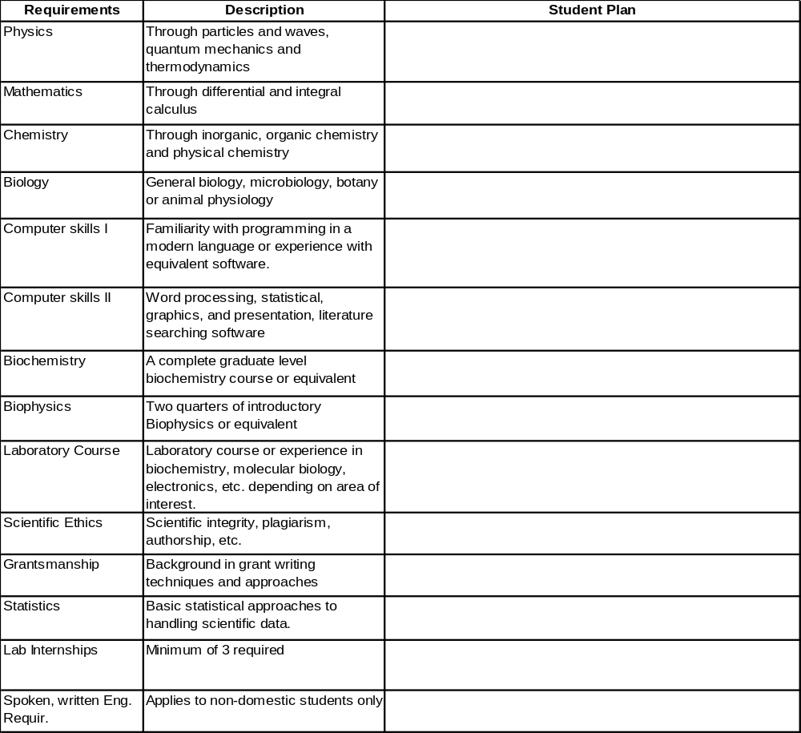

Ohio State University Biophysics Student Pre-Contract (cont.)
The Biophysics training track that most closely describes my current primary research direction interests is _____________________________________________________
The Biophysics track that is the next closest description or an area I am also interested in is ___________________________________________________________________
I have discussed my planned curriculum with the following three faculty within the Biophysics Program ____________ _____________ ______________
Appendix B Biophysics Program
Initial Worksheet for Planning 1st & 2nd Year Schedules.

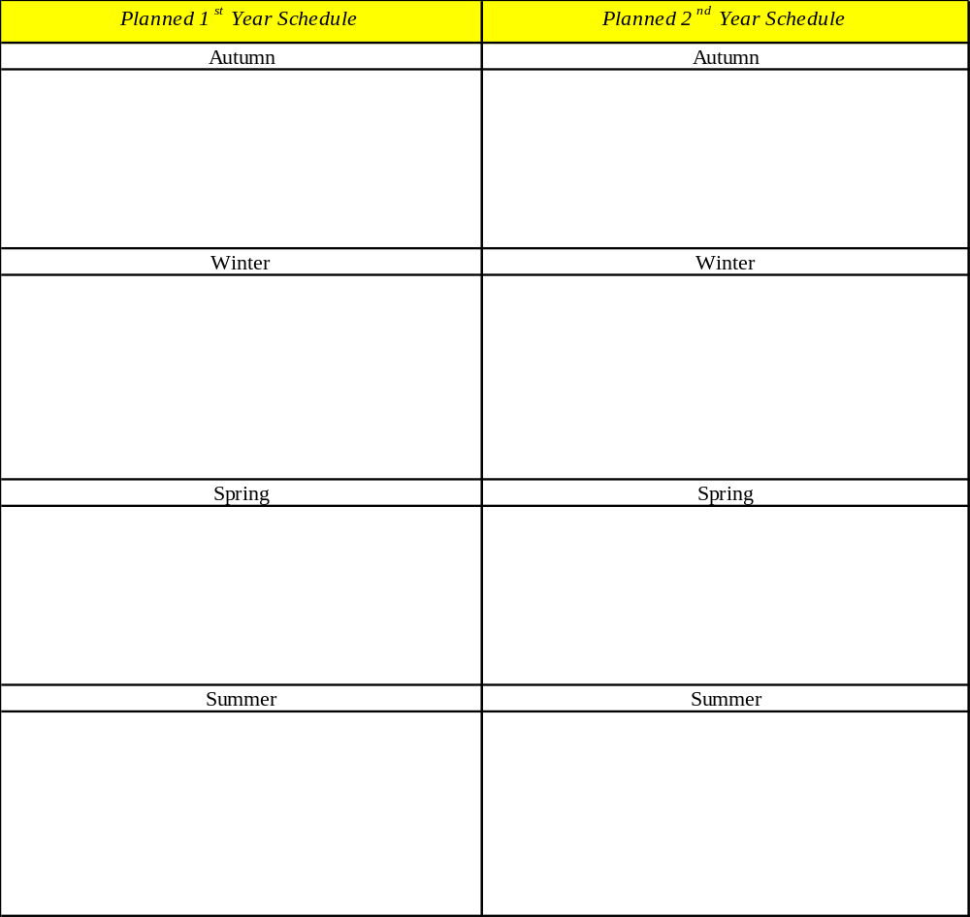

Student Signature___________________________________________ Date ______
Grad Studies Chair/Program Director Signature_________________________________ Date ______
Appendix C

BIOPHYSICS RESEARCH INTERNSHIP (BIOPHYSICS 999) FINAL REPORT
Student Name ____________________________________ Date______________________
Rotation Instructor _________________________________

SECTION 1: Expectations: This section should be completed by agreement of the student and faculty member at the beginning of the internship.
1. 999 credit hours enrolled: ___________
2. Estimated hours per week available this quarter for laboratory rotation by the student_________
- Expectations of the faculty member
- Reading relevant literature _____________________________________________________
- Experimental work ___________________________________________________________
- Research meetings ___________________________________________________________
- Student presentation__________________________________________________________
- Shadowing experiences________________________________________________________
- Time in the laboratory _________________________________________________________
4. Did you discuss together the possibilities for support of students in this laboratory over the coming year? Yes or No

Signatures: Student _____________________ Faculty ________________________ Date:_____

SECTION 2: Accomplishments of the Student. This section should be completed by the student after the rotation is completed.

1. Approximate average hours/wk participation in rotation: __________________
2. Number of weeks of rotation: ________________________
3. Direct participation in research work: (use additional pages as necessary):___________________
_______________________________________________________________________________
4. “Shadowing” experiences (use additional pages as necessary):_____________________________ _______________________________________________________________________________
5. Outside reading/literature study (briefly describe, use additional pages as necessary):__________ _______________________________________________________________________________
6. Presentations in research group meetings (use additional pages as necessary): ______________
_________________________________________________________________________________
7. Approximate time spent with the advisor: _____________ average hours/week.
8. Approximate time spent with other mentors in the lab (students/postdocs/techs/):________________
9. Other activities (use other pages as necessary) __________________________________________
________________________________________________________________________________________________________________________________________________________________________

Student Signature ___________________________ Date_________________

SECTION 3: Faculty approval:
1. Agree or Disagree that the student has participated in these activities as stated above.
2. I have have not discussed potential opportunities/support for doing graduate work in my program.
3. General comments, and recommendations regarding areas or study, courses, or lab courses that this student would need before entering into the lab?_________________________________________________ _________________________________________________________________________________

Faculty Signature: ____________________________ Date:_________________
Student, send one copy to the BIOPHYSICS OFFICE c/o Susan Hauser, 2031 Physics Research Building 191 W Woodruff Ave, Give one copy to your 999 instructor and keep one copy for yourself.
Appendix D
OSU Biophysics ProgramContract

Student Name: ____________________________________________ Date:________

Target Preliminary Exam Date: ____________
Target Written Qualifying Exam Date: ____________
Target Oral Qualifying Exam Date: ____________

LIST of COMMITTEE MEMBERS and SIGNATURES

By signing this document, the Committee has agreed upon the course of study and curriculum plan as outlined in this document and on the areas to be covered in the Preliminary and Qualifying Examinations

- Advisor: ___________________________________________

Signature: ______________________________________________

. 2. Committee Member:___________________________________

Signature: ______________________________________________

. 3. Committee Member:___________________________________

Signature: ______________________________________________

. 4. Committee Member:___________________________________

Signature: ______________________________________________

5. Committee Member:___________________________________

Signature: ______________________________________________

.
Contract Format (cont.)
Provide on these pages a) your current biosketch (Form Appendix F) and b) the instructions on how the preliminary and qualifying examinations will be performed for the benefit of all faculty on the committee. The student can cut and paste the relevant rules of the qualifying examination here from the preceding text, where appropriate. Omit the long passages regarding the format, etc.
Contract Format (cont)
COURSE WORK TAKEN

Department | Course | Title | Credit Hours | Quarter
 | 999 | Graduate Thesis Research
Add rows as needed

Total credit hours of fundamental curriculum _________________________

Total credit hours of core curriculum __________________________

Total graduate credit hours completed _________________:

Courses to be completed during remaining training
Department | Course | Title | Credit Hours | Planned yr/ Quarter

Contract Format (Cont)
Background and summary of research focus and career plans to this date:
Summarize your primary research focus, the general direction of your thesis work, and your long-term career plans.

Add additional pages as necessary for this description.
Information to be covered on the Preliminary Exam (repeat for each committee member)

Advisor/Committee Member: _________________________________________________
List of material to be covered: (NOTE: the contract can include areas of expertise that the student should know, particular biological systems that the student should become familiar with, important biophysical methods, and underlying physical principles that are fundamental to the field of biophysics or are behind the methods or biological phenomena of relevance to the student’s area of interest. This may be described in the form of courses that the student has taken, books and articles on a given topic that the student should be responsible for, or simply broad topics of knowledge.)
Appendix E

TIMETABLE/WORKSHEET FOR BIOPHYSICS STUDENTS

Year | Quart | Activities | Support | Submit
Pre | Pre | If available, classes and Internship | Program | Precontract
1 | Au | Classes/Internship | Program
 | Wi | Classes/Internship | Program
 | Sp | Classes/Internship/final Selection of Advisor | Program
 | Su | Classes/Research/Selection of Exam Committee | Advisor
2 | Au | Classes/Research/ Agreement on Contract | Advisor | Contract
 | Wi | Classes/Research | Advisor
 | Sp | Classes/Research | Advisor | Preliminary exam
 | Su | Classes/Research/ Preliminary Exam | Advisor | Preproposal  Qualifying Exam
3 | Au | Research/ Qualifying Exam | Advisor | Oral Exam
 | Wi | Research | Advisor
 | Sp | Research | Advisor
 | Su | Research | Advisor
4 | Au | Research | Advisor
 | Wi | Research | Advisor
 | Sp | Research | Advisor
 | Su | Etc. until Thesis defense | Advisor

Appendix F
Biographical Sketch
NAME | POSITION TITLE (e.g GTA, Program, Year)
Education/Training
INSTITUTION AND LOCATION | DEGREE  (if applicable) | YEAR(s) | FIELD OF STUDY

Date of admission: Current date:

Primary training division and area of research interest:

Advisor:

Teaching experience:

Previous positions and appointments:

Honors and Awards:

Peer-reviewed research publications:

Other publications:

Abstracts and national or international presentations:

Grants applied for/ received:
Appendix G

EXAMPLE OF THE FORMAT FOR THE ADVISOR”S PREPROPOSAL ASSURANCE LETTER

Date
Biophysics Graduate Studies Committee
2031 PHYSICS RESEARCH BUILDING
191 W WOODRUFF AVE

Dear Members of the Biophysics Graduate Studies Committee:

I am the advisor of NAME OF STUDENT who has submitted his/her pre-proposal for acceptance by the examination committee. I understand that the purpose of this exam is to evaluate the creativity, problem solving ability, communication skills, and overall background of the student. I assure the Graduate Studies Committee that at least two thirds of the aims and objectives of the proposal on which the student is working, represent the creative input of the applicant to the subject of his/her proposed thesis project. This component of the aims extends far beyond specific aims or objectives generated by me or those generated by my laboratory staff and do not represent aims of existing funded or pending projects and they represent the creative contribution of the student towards the project.

Sincerely,

FACULTY NAME and Signature
Appendix H Biophysics Leave Of Absence Form
 | Request for Leave – Funded Graduate Students  This form is used to make and approve leave requests for Graduate Associates, Fellows, and Trainees paid through the Ohio State payroll (funded graduate students). Requests for leave from appointment duties should be made as far in advance as possible. Students on leave from their appointments must generally continue to meet minimum registration requirements.
Section I. To Be Completed by the Student and Submitted to Appointing Unit Supervisor

Student’s Name (Print): ________________________________________________________________________

Student’s Appointing Unit: ___________________________ Student’s Graduate Program: _________________

Student’s Appointment Type (check one):
- Graduate Associate (GTA, GRA, GAA)
- Fellow
- Trainee
Leave Designation (check short-term absence or leave of absence and reason for request):
- Short-term absence (generally one to three days; may be up to two weeks in rare circumstances) | - Leave of absence  (See definitions on page two; attach appropriate  documentation in support of the request.)
- Personal illness/injury | - Personal serious health condition  - Care for an immediate family member  with a serious health condition  - Childbirth or adoption
- Death in family
Other (explain): ____________________
______

Dates of Requested Absence: From _____________________ To __________________________
I certify that the information provided as part of this request is true, accurate, and complete. I understand that a person who, knowingly and with intent to defraud, requests leave using materially false information is guilty of fraud, which may result in disciplinary action, including action under the Code of Student Conduct.
Contact Phone Number (Required):________________________________________________________________
______________________________________________________________________________________________
Signature/Date – Student: __________________________________________________________________

Section II. To be Completed by Appointing Unit Supervisor
Note: In the case of a leave of absence, the following signatures are required: the appointing unit supervisor; the student’s advisor; and the student’s graduate studies committee chair. Once a decision has been made, a completed copy of the form should be returned to the student requesting leave.

Action
- Approved.
- Not approved. Comments (or attach explanation): _____________________________________
____________________________________________________________________________________
Signature/Date - Appointing Unit Supervisor: ______________________________________________________

Signature/Date (required for leave of absence) - Student’s Advisor: ______________________________________

Signature/Date (required for leave of absence) - Graduate Studies Committee Chair: _________________________
Appendix I
Biophysics faculty agreement to become the Ph.D. advisor

Faculty Name (print)_______________________________

Student Name (print)_______________________________

I have agreed to mentor this student as a Ph.D. advisor within the Biophysics Program. I understand that by agreeing to be the primary advisor I take the responsibility to steward this student through to his/her Ph.D. degree, as long as he/she meets my expectations and the expectations of the examination and thesis committees.

I am familiar with the rules of the Biophysics Program as outlined in the Faculty Handbook and I take responsibility for ensuring that the regulations set by the Biophysics Program and the OSU Graduate School are met during the course of his/her education.

I agree to take the lead with respect to advising this student on the necessary coursework and course of study with the goal of successfully graduating and having the greatest opportunity for success after graduation. I will confer with the Cirector(s) and members of the Graduate Studies Committee to accomplish this goal.

I plan to support the student at $_____________ /yr during training, starting on ___________ (date) by the following mechanisms:

a) NIH Grant support, b) NSF Grant Support, c) Teaching assistantship, d) Other support.

I plan to support the student’s tuition and fees in the following way:

I have:
Category “P” _____ or “M” _____ graduate status in the Biophysics Program, or
_____ I have no graduate status in the Biophysics Program and am planning on applying.

Please note, signing this form is not legally binding in any way. However, it provides the program with some understanding of the level of commitment you are willing to give to this student and provides a mechanism for us to track whether the student has made concrete efforts at realistically finding a laboratory for research mentorship and support.

Name of Faculty Member ______________________________________________

Date:____________________________________________

Students, send one copy to the BIOPHYSICS OFFICE, c/o Susan Hauser, Biophysics, 191 W Woodruff Ave.
Give one copy to your 999 instructor and keep one copy for yourself.

Appendix J: Quick chart for candidacy exam

Time Student Advisor Committee members

1. Before end of 9th quarter send questions to student
and Program Administrator
2. up to 7 days later send answers to committee
3. up to 7 days later report result to student and send grades to advisor
Program Administrator
4a. up to 2 months later back to 1. if first exam failed
(at most once)
4b. up to 2 weeks later send pre-proposal to committee send 2/3 letter to Program
Administrator
5. up to 1 week later report (dis)approval to send (dis)approval to advisor
student and Program
Administrator
6a. up to 1 week later back to 4b if not approved
(at most twice)
6b. up to 4 weeks later send full proposal to committee
7. up to 1 week later report (dis)approval to send (dis)approval to advisor
student and Program
Administrator
8a. up to 4 weeks later back to 6b if not approved
(at most once)
8b. immediately file Graduate School form
for oral exam
9. about 2 weeks later oral exam

Make additional copies of this page as necessary for each committee member
The OHIO STATE BIOPHYSICS GRADUATE PROGRAM Use Continuation pages as necessary

